STAR TREK
UNCHARTED
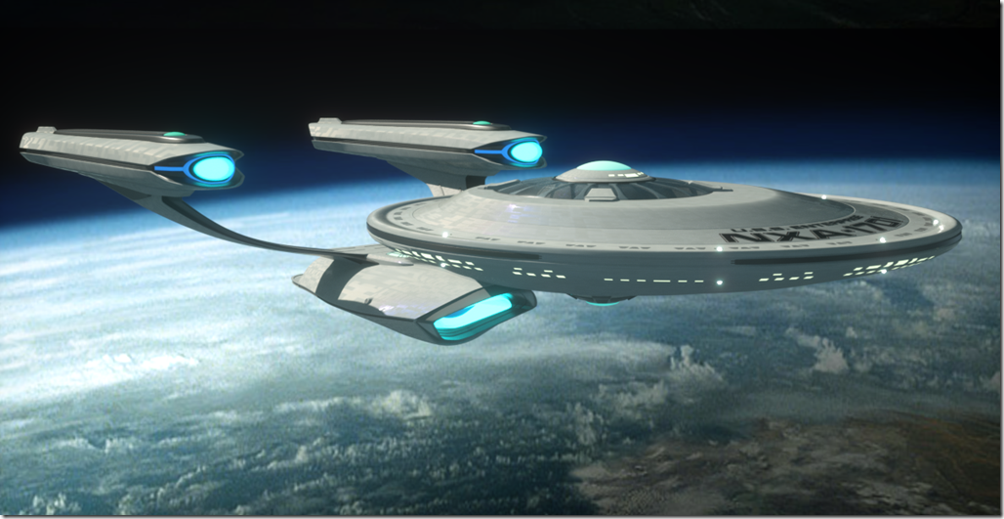

USS Enterprise
NXA-1701
Perseus Class
Intergalactic Exploration Starship

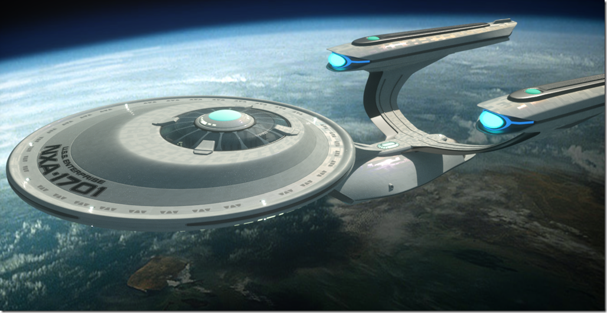

Mission:
- To explore the Andromeda Galaxy.
- Seek out new life and new civilizations.
- Establish first contact.
- Form alliances and diplomatic relations.
- Joint mission between Starfleet and civilian scientists

Setting:
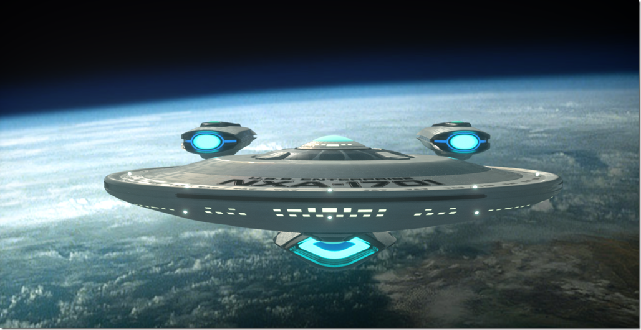
- 200 years after Kirk & original Enterprise
- New technology developed – a Spacefold Gate constructed to warp jump to Andromeda.
- Enterprise is the first ship assigned to the new galaxy.
- Other ships will follow after first season.
- Starbase being built, will be complete at end of first season and two more ships will arrive.
- Enterprise will occasionally return to Milky Way for staffing changes, refits, extended leave.
Crew
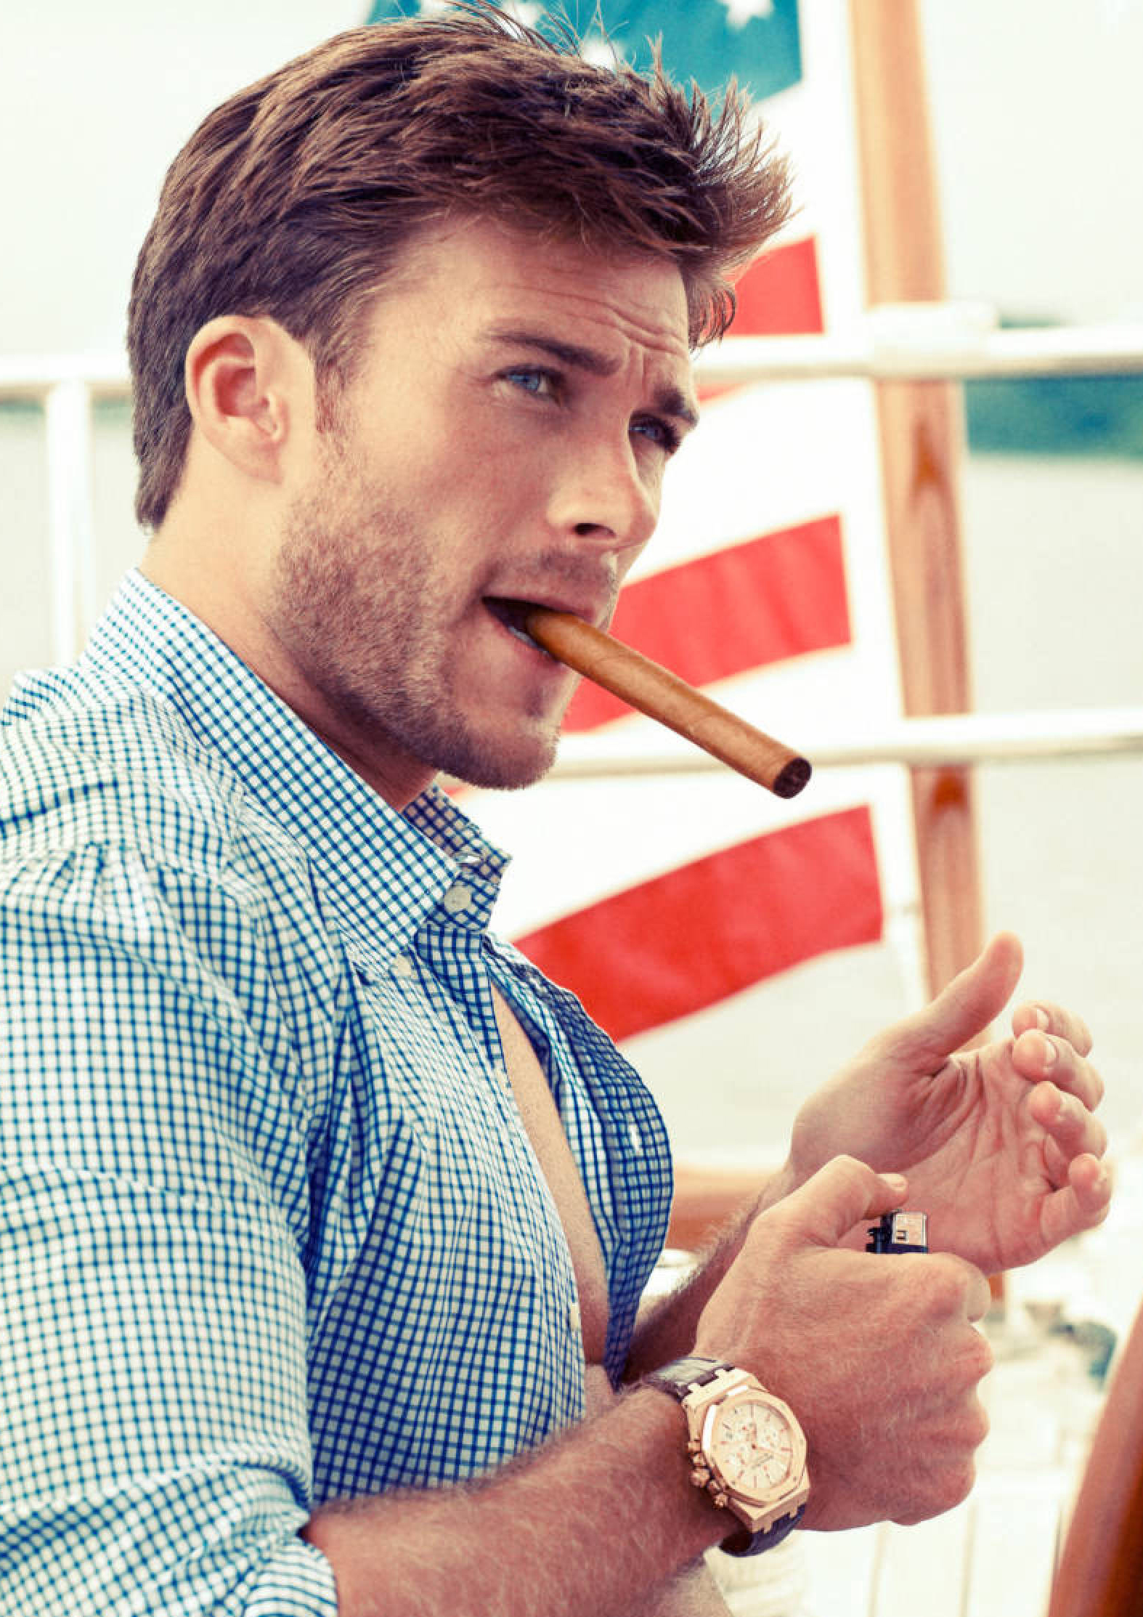

Expedition Leader (Civilian)
Cole Weston
Male, Mid-30’s
Terran (Caucasian)

Born on a frontier planet.

Adventure-seeking explorer with a case of wanderlust.

Well-respected among Starfleet, was considered to have a promising future, but resigned his commission to explore the galaxy.

Captain
Solon Vega
Male, Age Unknown
Xian/Terran (Asian)

Half-Human, half-Xian. Born and raised on Elysia IV, a secretive culture that believes they can sense their own future.
Cole’s Academy classmate, former shipmate and his oldest friend and confidante.
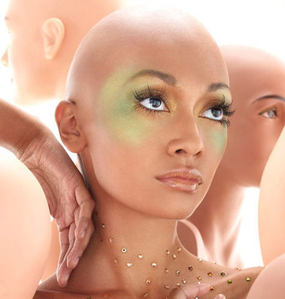

Sciences Director (Civilian)
Lexia
Female, Early 30’s
Deltan

The foremost Xenobiologist in the Federation. An accomplished academic, but has never served on a starship before. Has an insatiable curiosity.

As a Deltan, has enhanced senses, is an empath (able to sense and transmit feelings) and is very active and open sexually.

Head of Health and Wellness (Civilian)
Firela Zan Joli
Female, Mid-40’s
Suvani

Extensive background in infectious diseases and xenoviruses. Believes strongly in non-Interference.

All Suvani are female, reproduce through parthenogenesis seeded by tactile genetic exchange. Suvani are extremely potent touch telepaths.

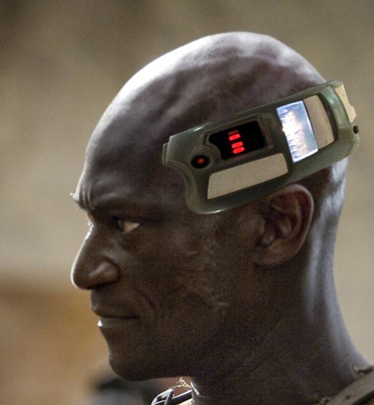
Tech/Ops Chief (Lt. Cmdr.)
Marcus Daystrom
Male, Mid-50’s
Terran (African)

A transhumanist, enhances his mental capabilities with neural implants. Networked directly into the ship’s systems. Creator of the ship’s AI, NOMI and of the holographic crewman ASH.

Great-grandfather was Richard Daystrom (invented duotronics, faulty M-5 that caused the deaths of hundreds of Starfleet personnel).

Security Chief (Lt. Cmdr.)
Qora
Bigendered, Late 20’s
Orion

Orions have superior strength and agility and a special few have amazing regenerative abilities.

An exile from Orion society for refusing to breed. 10% of Orion are born like her, “Avunari” (the “third kind”) – of male gender but with female secondary sex characteristics. Her kind are required to propagate the species and are kept hidden and repressed.

Is adept with hand to hand combat, melee weapon combat and energy weapons.

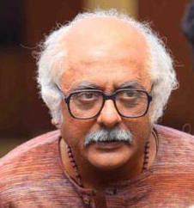
Chief Engineer (Civilian)
Dr. Tarun Karnik
Male, 60’s
Terran (Indian)

Experienced engineer and one of the designers and builders of both the new Enterprise and the Spacefold Gate.

Dr. Karnik is sometimes accused of being a “mad scientist” and has zero tolerance for incompetence. Anyone who doesn’t understand him he considers incompetent, and he will gladly tell them so.

Helmsman/Navigator (Ensign)
Viin
Female, Early-20’s
Romulan

Keen ability for spatial math and an expert helmsman. Like all Vulcanoid races, has very strong emotions and has a tendency to let them get the better of her, being still young and untrained in mental discipline.

Comes from a tribe of lighter-complexioned Romulans who have abandoned their old, Imperial ways and have embraced change after the destruction of Romulus. They believe in peace and exploration and have rededicated themselves to discovery and hypermathematics.

Xenolinguist/Crypologist (Lt.)
Nicolas Batista
Male, Late-20’s
Terran (Brazilian)
Brilliant linguist and cryptology savant. He finds any problem or puzzle irresistible, can decode most ciphers after just a cursory glance.

A low-level analyst for Starfleet Intelligence for several years, essentially drafted into serving on the Enterprise.

A genius at seeing patterns and understanding complex systems, sometimes his solutions appear, to the rest of the crew, to come out of nowhere.

Visual Reference

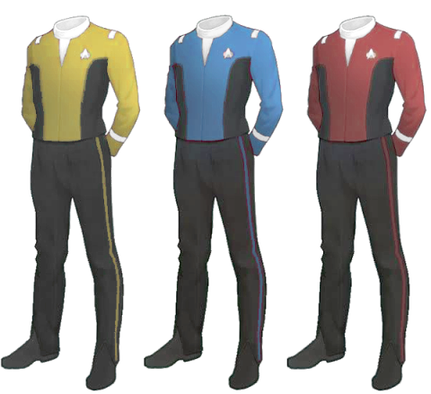

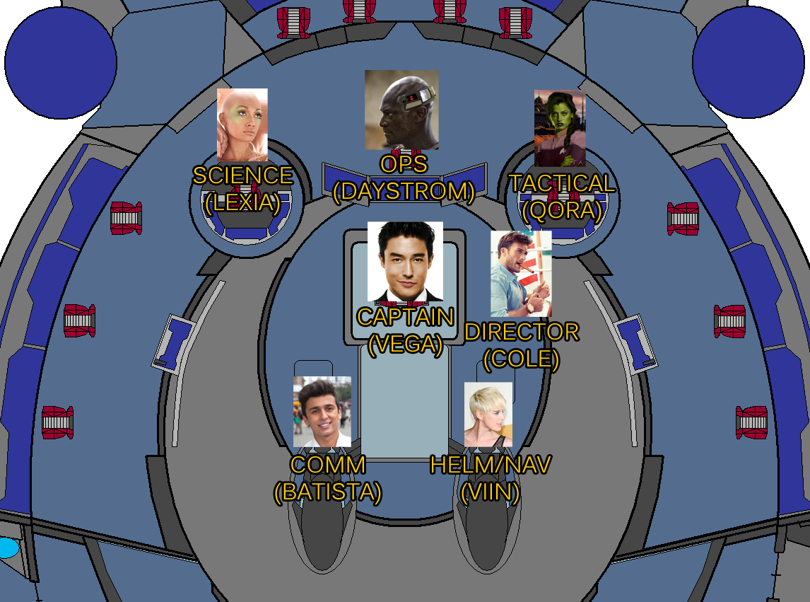

Star Trek UNCHARTED
Pilot
"Rendezvous with Destiny"
By:
Michael Chang Gummelt
mgummelt@gmail.com
6th Draft
7/31/2015

Ext. Frontier planet - night
The planet's surface is a broad, open plain with sparse vegetation. There are two similar sized moons and a smaller third one in the sky.
A single structure stands on the vast plain, a futuristic ranch house. Various pieces of agricultural science equipment and alien ranch animals are arrayed around it.
TITLE OVER:
The 25th Century...
A closer look at a second story window reveals a MOTHER (40) looking into a bedroom, turning on the light and seeing it empty. She goes to the open window and looks out.
Out in the field, YOUNG COLE (10) sits on a blanket with a pillow, looking up at the night sky. His FATHER (45) comes walking up behind him. The father is slim and tall and has a heavily wrinkled face that conveys a lot of character and experience for his relatively modest years. The father looks down at the boy, then up at the sky.
In the sky, along with the three moons, is an awesome view of the Milky Way Galaxy from the very outskirts. The planet is in a system at the edge of the Galaxy, looking back down on it.
The father looks down at the boy, unsure of whether to yell at his son or hug him. Instead, He looks up into the night sky, too, for a bit, then pats Young Cole on the shoulder and gestures for him to follow him.
Young Cole gets up and the two start walking.
YOUNG COLE
Where are we going?
Young Cole's Father nods up ahead and the two walk for a bit under the stars without talking.
The father stops walking and stops Young Cole, turning him to face him. He points up at the stars and Young Cole looks up.
Young Cole smiles at the stars in awe, wide-eyed.
FATHER
You'll be up there, before you know it.
The father then points outward at something in front of them. Young Cole looks.
There is a huge lake about 15 feet below a cliff. They're just a few feet from the edge. Reflected perfectly in the still lake is the night sky, creating the illusion that they're standing on the precipice of space, itself.
YOUNG COLE
(softly)
Whoa...
Young Cole walks up to the edge and looks down into the stars. His father walks up beside him and YOUNG COLE sees the reflection of his father looking over his shoulder.
FATHER
Someday, Cole, you're going to get a chance to do something nobody has ever done before.
(pause)
And when you do... I want you to jump.
Young Cole looks down over the cliff. He's awed, but apprehensive.
YOUNG COLE
(hesitant)
Is it dangerous?
FATHER
(thinks for a bit, then:)
All the best things are.
Young Cole looks deep into the starfield in the lake. It's reflected in his eyes.
FATHER (CONT'D)
(gently)
Jump, Cole.
(inspirationally)
Jump.
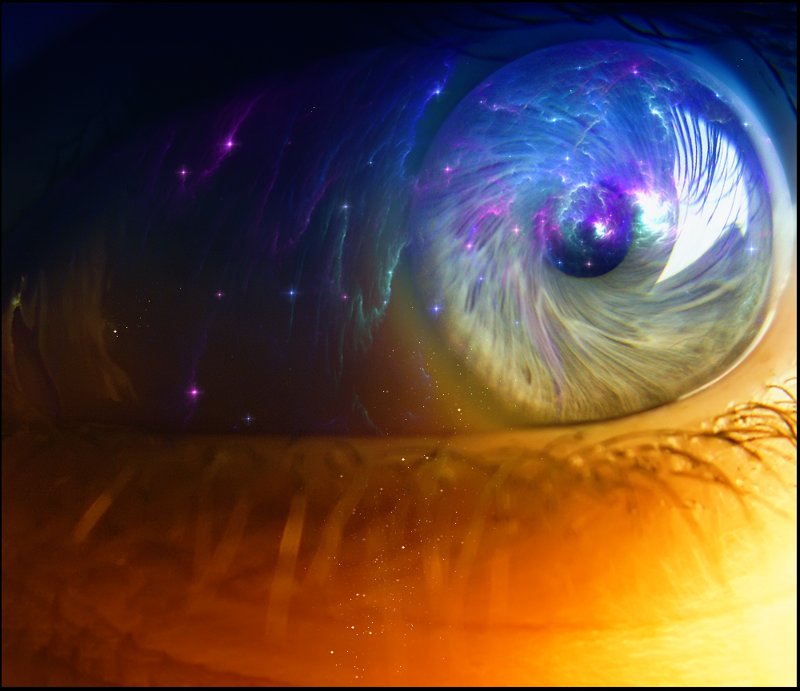
Young Cole dives head first into the lake, into the stars and he smiles in pure joy. Reflected in his eyes we can see the stars rushing at him.
Cut to:
Int. USS PEGASUS - BRIDGE
Continuing from previous shot. Close-up on an eye, bright streaks are reflected in them, showering out radially.
As the camera pulls out, we see that the boy is an adult, now, LT. CMDR. COLE WESTON (20-25). But his expression is not the peaceful, awestruck one of the child, but is disturbed and distressed. His face a bit bloodied and covered in soot, his hair disheveled. Slowly, ambient sound fades in. We HEAR sounds of chaos - alarm klaxons, crewmen shouting orders, weapons fire.
Then we see on the viewscreen what he was looking at - a starship exploding.
LT. SOL VEGA (20-25) sits at the console at the front of the bridge, beside helmsman Cole Weston. He is busily firing his weapons and looks down from the viewscreen at his console.
Vega
Direct hit, Captain!
Behind the two young men, sitting in the Captain's chair is the experienced, grizzled CAPTAIN OVIEDO SAN LAGOS (55-60). He leans forward to shout to the two crewmen over the din.
Capt san lagos
Keep on them! Helm, hard to port! Vega, as soon as they're in range, give me a full torpedo spread!
He sticks out a hand spreading his fingers in the firing pattern he's requesting.
Cole
Captain, shields down to 10 percent! Taking damage on the main thrusters! She's sluggish as Hell, sir!
The ship rocks from weapons fire. Sparks fly on the bridge and a crewman falls. Capt. San Lagos points to them and the Doctor, who was tending to another wounded officer, runs to them.
vega
Enemy vessel coming up astern!
CapT SAN LAGOS
Divert all power to the aft shields-
Another couple shots hit them.
COLE
Shields are down!
CAPT SAN LAGOS
Aft torpedoes!
VEGA
Aft torpedoes, aye, sir!
EXT. SPACE - IN Orbit around OMICRON CETI V
The USS Pegasus fires torpedoes out of its rear launchers and the camera tracks their flight towards a much larger, predatory looking ship - a Romulan Warbird. Its disruptor fire destroys the torpedoes and it falls in behind the USS Pegasus. Its weapons charge up to deliver the fatal blow to the battered, limping starship.
Int. USS PEGASUS - BRIDGE
Lt. Vega is watching his instruments.
VEGA
Negative impact, sir!

Capt saN LAGOS
(to someone behind him)
Aft view!
The viewscreen changes to show the view out the back of the ship. The starboard nacelle is missing, its strut leaking a radiation trail into space. The ship is listing and sluggish. And the Warbird is settling in right behind it to finish them off.
Vega, Weston and Capt. San Lagos watch in mortal fear.
EXT. SPACE - IN Orbit around OMICRON CETI V
The Romulan Warbird unleashes its weapons upon the smaller ship. Its beams tear across the hull, ripping it open and doing devastating damage, knocking the smaller ship off-course.
Int. USS PEGASUS - BRIDGE
Vega, Weston and Capt. San Lagos are thrown from their posts, explosions rock the bridge.
Vega tries to climb back up to his controls.
VEGA
I can try to target their weapons-
COLE
Captain, the crew!
Capt. San Lagos looks around at his bridge. Many are gravely wounded, some are dead... including the Doctor, staring at him with lifeless, surprised eyes. Capt. San Lagos feels the life run out of him and his face falls in resignation.
CaPT SAN LAGOS
(to Cole)
Signal all decks: abandon ship.
It hurts Cole to see the defeat in his Captain's eyes, but he turns to his console to give the order.
Lt. Vega sees something on the viewscreen his eyes widen.
VEGA
(pointing)
Captain!
EXT. SPACE - IN Orbit around OMICRON CETI V
Looking backwards from the top of the heavily damaged USS Pegasus, we see the Warbird charging up for a final volley when, behind it another Starfleet ship rises up from behind it accompanied by a victorious MUSICAL FANFARE. It has a familar shape - a disc-shaped primary hull connected by a neck to a tubular lower, secondary hull and two long, graceful nacelles swept back and high.
Its name can be read on its primary hull: USS ENTERPRISE!
Int. USS PEGASUS - BRIDGE
VEGA
(smiling)
It's the Enterprise!
Cole looks at the screen in awed disbelief. Capt. San Lagos stands up, staring at the screen in anticipation.
Int. USS ENTERPRISE - BRIDGE
This bridge is damaged as well, but in better shape than the beleaguered Pegasus.
A handsome, charismatic young CAPTAIN JACKSON DRAKE (35) leans forward and clenches his fist as he gives the command:
Capt drake
FIRE!
EXT. SPACE - IN Orbit around OMICRON CETI V
The Enterprise launches a surprise volley of phaser fire and photon torpedoes at the unsuspecting Romulan Warbird, striking several key points and throwing off its own attack.
The Warbird begins to turn to fight back, but the Enterprise launches another volley and the Warbird cannot respond. It reels and falls away, exploding in an incredible ball of fire.
Int. USS ENTERPRISE - BRIDGE
LT. TIMURA (20-25), a young, focused female tactical officer turns to Capt. Drake.
Lt timura
The Warbird has been destroyed, Captain!
There are CHEERS and celebrations on the bridge.
Captain Drake stands up and steps forward between Lt. Timura and his helmsman, a thin, dark-haired young man (25).

CapT DRAKE
Raise the Pegasus.
Transporter room, prepare to beam the wounded to Sickbay.
Captain San Lagos appears on the viewscreen.
Capt SAN LAGOS
Captain Drake, the Enterprise is a sight for sore eyes!
CAPT DRAKE
Thank you, Captain San Lagos. Let’s get your people off of there before-
Suddenly an alarm at one of the rear stations goes off. Captain Drake turns to look back at it. A bald alien crewmember with green skin (COMMANDER AXON, 40) is reading a screen in concern.
CapT DRAKE (CONT'D)
Chief Axon, what is it?
Capt. Drake jogs over to take a look himself.
Cmdr axon
Captain... I'm detecting a massive radiation leak... The explosion from the Warbird must have breached the warp core containment system!
In alarm, Capt. Drake looks at the viewscreen.
CAPT DRAKE
Captain! We need to get your people off of there right now!
CMDR AXON
Captain, no! It's not them... it's-
EXT. SPACE - IN Orbit around OMICRON CETI V
Suddenly, the back of the USS Enterprise's main hull explodes and splits the ship in two. The halves fly away from each other, a chain reaction of explosions almost completely destroying them.
Int. USS PEGASUS - BRIDGE
Lt. Vega, Lt. Cmdr. Weston and Capt. San Lagos watch in utter shock as they witness the Enterprise explode on their viewscreen.
Lt. Vega can't believe it, Lt. Cmdr. Weston looks sick and Capt. San Lagos sinks back in his chair. None of the men speak for a moment as they witness the flaming remnants of the once beautiful ship streak across space like crackling embers from a firework.
CaPT SAN LAGOS
Send on all channels: distress code one-
COLE
Captain, I recommend we man the lifeboats.
CAPT SAN LAGOS
(incredulous)
Abandon ship...?
COLE
No, Captain: We might be able to rescue some survivors from the Enterprise.
Lt. Vega stands up, he agrees.
VEGA
The lifeboats are on the bottom of the hull. We took no damage there, they should all be functional!
Capt. San Lagos gets it and nods.
CapT SAN LAGOS
Take three teams, use all the boats. I'll go down and get what's left of Sickbay ready.
As the three men head for the rear of the bridge, towards the turbolift, a message comes on the main viewscreen.
A tired, weary-looking ADMIRAL COMSTOCK (55) appears.
Adm comstock
Attention all Starfleet vessels. The Galactic Federation has reported that the Klingons have claimed victory over the Romulans.
Lt. Vega and Lt. Cmdr. Weston look at Capt. San Lagos in shock.
AdM COMSTOCK (CONT'D)
Praetor Vokar is dead, the Senate has been destroyed... the Romulan Empire has fallen. The war is over.
There is a brief look of relief on Capt. San Lagos' face, at long last. But he only allows himself this catharsis momentarily, turning to the two junior officers and hurrying them along into the turbolift for their rescue mission.
The turbolift doors close on their battle-worn faces.
Ext. StaRFLEET HQ - day
The PRESIDENT of the Galactic Federation (50) is at a podium, giving a speech.
President
...and with this victory, all free people can finally awaken from the long, terrible nightmare that set our Galaxy ablaze. No longer will the forces of oppression and tyranny terrorize those who value freedom and liberty.
As we continue to HEAR the President's speech as VOICE OVER, we see medals being pinned to Capt. San Lagos:
PRESIDENT (V.O.)
And it is due to the bravery and selfless sacrifices of our fine Starfleet men and women, our defenders and protectors, that we have secured this freedom.
Lt. Vega:
PRESIDENT (V.O.)
But we still have work to do. Our new Galactic Federation is still young and fragile. In unity, we defeated the forces of evil, but we must never again let our differences divide us.
And Lt. Cmdr. Weston:
PRESIDENT (V.O.)
Me must remain ever vigilant, ever ready to defend ourselves against those who hate freedom. We will rebuild, and we will be stronger than ever before!
The crowd's applause is deafening.
We hold the shot on Lt. Weston and can see that he is uncomfortable with the words he's hearing and the medal he's getting. He is a troubled, conflicted young man.
The applause is a SOUND BRIDGE to the next scene as we
CROSS FADE to:
Ext. StaRFLEET HQ BALCONY - NIGHT
Establishing shot: a post-ceremony party is being held in a banquet hall. The uniformed celebrators can be seen through the windows and open bay doors of a wrap-around balcony.
INT. starfleet hq - night
Lt. Cmdr. Cole Weston sits, his dress uniform unbuttoned, holding his medal, looking at it.
Around him, other Starfleet officers and crew are talking and drinking. Lt. Vega seems particularly animated and outgoing, entertaining a small group of women and junior officers.
Cole walks out of the banquet hall onto the balcony.
Capt. San Lagos sees Cole leaving and excuses himself from his current conversation.
Ext. StaRFLEET HQ BALCONY - NIGHT
Cole Weston walks up to the railing and looks down over San Francisco Bay. He sees the stars reflected in the water. He looks, again, at his medal.
Capt. San Lagos takes up a spot beside him at the railing.
CAPT SAN LAGOS
Cole.
COLE
Captain.
CAPT SAN LAGOS
We're off duty, call me Oviedo.
Cole doesn't respond. He's just looking at his medal, turning it over in his hands.
CapT SAN LAGOS (CONT'D)
Cole. I want you to know... you really proved yourself up there.
Still nothing.
CAPT SAN LAGOS (CONT'D)
I've always had faith in you, since the Academy. I knew you were destined for great things, but out there I saw-
COLE
Captain-
CAPT SAN LAGOS
Wait. Listen. Before you say anything... I want you to be my first officer.
Cole looks at Capt. San Lagos as if he's crazy.
COLE
What?!
CAPT SAN LAGOS
I know it's quick, but you're on the fast track to Captain and-
ColE
No!
CAPT SAN LAGOS
(shocked)
...What?
COLE
No, Captain... Oviedo. I don't want... I never wanted...
CAPT SAN LAGOS
(aggressively)
Cole, you're still-
(backs off a bit)
It's okay, you need some time...
Cole sighs and looks out over the water and up at the stars. He closes his eyes and looks peaceful for a moment. He looks back at Capt. San Lagos.
COLE
I joined Starfleet to see the stars, Oviedo. To be out there, exploring the Galaxy, discovering the unknown... not... not this.
He holds up his medal.
CAPT SAN LAGOS
Cole... this war... it's all you've known. It hasn't been fair to your generation, but it's over now and-
COLE
It'll never be over, Captain. There are always wars. And Starfleet will always be there to fight them.
CAPT SAN LAGOS
(not making apologies)
It's... our duty, son.
COLE
And I've done my duty. Now I want my life.
Cole sets down his medal on the railing and walks away, down the balcony away from the banquet hall.
Lt. Vega comes up and sees Cole walking away. He shakes his head and smiles at Capt. San Lagos.
VEGA
I see Cole's the life of the party as usual.
Capt. San Lagos picks up Cole's medal and looks at it ruefully.
Lt. Vega sees that it's Cole's. He takes it and turns to go after Cole.
VEGA (CONT'D)
Hey, Cole-!
But Capt. San Lagos grabs his arm and holds him back. Vega looks quizzically at Capt. San Lagos and then after Cole. Then he looks down at the medal and he gets it. He's disappointed, but not surprised. His shoulders fall.
VEGA (CONT'D)
Damn.
(sighs)
I should have seen it coming.
Capt. San Lagos puts his arm around the young officer and the two walk back into the banquet hall.
Ext. eaRTH - san francisco - night
Sky traffic passes by sleek, modern buildings lit from within. One is a tall, rounded building with wide semi-circle windows that lead out to semi-circular balconies. Push in on one of these apartments.
Int. Lexia's apartment
Cole is lying in bed on his side, eyes open, thinking. No longer a clean-shaven Starfleet officer, he has a week of stubble.
Lying behind him in the bed is a bald Deltan woman, Lexia (20).
Behind Lexia, another woman (alien, previously unseen) gets up out of the bed, nude, and heads for the bathroom.
Cole sits up and Lexia stirs and touches his arm. He reacts with visible appreciation to her touch.
LEXIA
Leaving so soon?
Cole smiles at her.
Cole
I have to see a Breen about a ship.
LEXIA
(seductively)
Right now?
COLE
(sighs, doesn't want to leave)
I have to review the rest of the crew applications by morning.
Lexia smiles and sits up. She punches him in the shoulder.
LEXIA
Look at you! Got to be Captain of your own ship after all!
Cole smiles as he puts on his boots.
Lexia leans in and points a finger in his chest lovingly.
LEXIA (CONT'D)
And on your own terms.
ColE
I can't wait to get out there, Lex.
LEXIA
I'm so proud of you. This is what you've always wanted, not marching around like a toy soldier for Starfleet. You were meant to be free.
Cole takes her hand.
COLE
We're kindred spirits that way, I guess.
Lexia smiles and kisses his hand.
Cole stands up and pulls on his shirt - these are civilian clothes now.
Cole (CONT'D)
Everyone says there's no frontier left, but when you and I get to the outer arms-
Lexia's smile fades and turns to regret.
LEXIA
Oh, Cole... I didn't... I can't go with you!
COLE
(shocked)
What?!
Lexia sits up on the edge of the bed, also nude.
LEXIA
Cole, I have a career I'm building here... I can't just drop it all and go-
COLE
(getting upset)
Lex! This is all we ever talked about - running away together to see the Galaxy!
LEXIA
(delicately)
It's all you ever talked about...
Cole is beside himself. He can't believe she would let him go that easily. He paces and Lexia watches him with concern.
He looks at her as if to say "really?!" and she shrugs apologetically. He gives her a look like she just slapped him in the face. In a huff he grabs his jacket and turns for the door.
COLE
(not looking at her)
I guess it's easy for you to say goodbye. What's one less lover to you?
Lexia is hurt, angry now. She stands up and grabs him from behind, but he doesn't turn or look at her.
LEXIA
You know that's not fair! You knew Deltans were polyamorous when we met! I was completely honest with you!
Cole doesn't respond. She moves around in front of him and cradles his face. He doesn't want to look at her.
LEXIA (CONT'D)
Cole... my love for you is just as strong as yours is for me. I just... have more of it to share.
The woman has come out of the bathroom now and sees the two. Cole glances in her direction.
Cole
I don't want to share.
LEXIA
I... I have no room for jealousy, Cole.
Cole grabs her wrists and pulls her hands away.

COLE
You've got no room for me.
Cole pushes past her and leaves. The doors close behind him.
LEXIA
(sighing)
Humans.
The alien woman comes up to Lexia and puts one arm around her and another on her shoulder. Lexia smiles ruefully and puts a hand on the woman's hand. The woman leans in and kisses Lexia and the two fall back into bed together.
Ext. EarTH orbit - space dock
A few crew are standing around at a docking port as supplies are being loaded on. They look like a mixture of scruffy scientists and grungy ship maintenance crew. One seems to be in charge (SHIP'S MATE, 45) and is checking things off on a digital PADD as crew and equipment is loaded on.
Cole walks up to the ship’s mate.
ShIP'S MATE
(nods)
Skipper.
Cole nods to the ship's mate as he stops and looks around behind him at the dock, expectantly.
Ship's mate (CONT'D)
We can hold the launch if you're waitin' to say some farewells.
Cole looks around. Nobody is coming. He shakes his head.
Cole
I've waited long enough.
Cole and the Ship's Mate follow the last of the crew and equipment inside and the hatch closes behind them.
Ext. space
A starfield. Cole's ship appears from the bottom of the screen and sails off into the stars, fading away into the blackness.
Fade out.

MAIN TITLE:

STAR TREK UNCHARTED
ExT. Space - ACHERON OMEGA III
In orbit above an orangish, desolate-looking planet.
A medium-size Starfleet science vessel, the USS MESSIER, comes from behind the camera and moves into orbit.
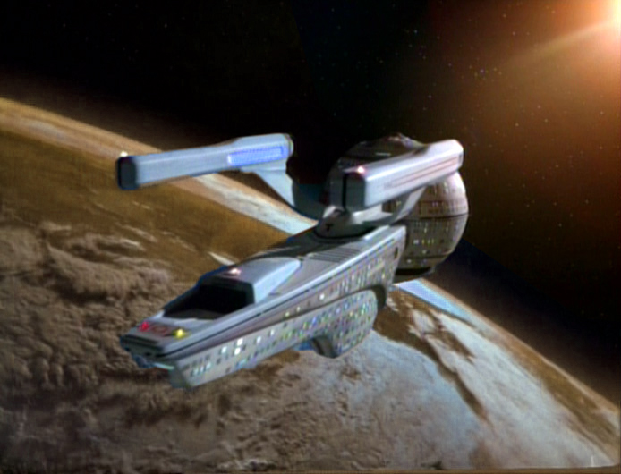
TITLE OVER:
Acheron Omega III
"Karnik's Planet"
EXT. KARNIK'S PLANET - SURFACE
An open orange dusty plain at the base of an outcropping of rocks. There is sparse green-brown vegetation.
Four figures materialize.
One is obviously a scientist: PROFESSOR ULIO (55), an older blue-skinned Bolian who appears excited and anxious.
The second is NELSA (30), a female humanoid with olive skin, short, curly dark hair and dark eyes. She appears to be more of a brooding type. She looks alert and focused and wears a phaser.
They are accompanied by a serious-looking junior security officer, LT. RODRIGUEZ (25), who is well-built and has a short crewcut. He also wears a phaser.
Prof. Ulio looks around. He looks at the top of the rock formation and points. The landing party looks up, Karnik's ranch can be seen at the top.
The three proceed up the rocks.
INT. KARNIK'S RANCH
Through a window, we see the four figures ascending the rocks. A hand lets go of the curtain and picks up a device.
EXT. KARNIK'S PLANET - SURFACE
As the landing party reaches the top of the rocks, they come to a small plateau.
Lt. Rodriguez spots a sign that says:
WARNING: TRESPASSERS WILL BE DISINTEGRATED!
His eyes widen in alarm. He looks around and puts his hand on his phaser, gripping it anxiously.
They see Karnik's Ranch, a somewhat humble looking shack.
KARNIK (O.S.)
You know, I haven't gotten to disintegrate someone in a long time.
All three turn and see KARNIK (55), who has materialized out of thin air behind them. He is an older Indian man, looking a bit ragged and weatherworn. But he is still quite spry and mentally sharp. Alert brown eyes peer out from his squinting, wary expression. His thin, tight-lipped mouth is always in some degree of a frown. He's pointing the device at them like a weapon.
Lt. Rodriguez goes to draw his phaser, Nelsa stops him.
ProFESSOR ULIO
Dr. Karnik, at last! We've traveled three months to see you-
KARNIK
(scoffs)
You could have done it in three days if Starfleet would have listened to me the last time they sent a couple of so-called "engineers" to evaluate my theories.
NELSA
(under her breath, to Prof. Ulio)
That's Karnik? Doesn't look like a genius.
PROFESSOR ULIO
(ignoring Nelsa)
Dr. Karnik, it's those exact theories that have brought us here... Starfleet thinks it's time to give them a try.
KARNIK
Well... really. Why didn't you just say so in the first place?
Karnik lowers his device and walks past them into the house.
As he passes Lt. Rodriguez, he points his device at him and turns it on - it's just a flashlight. He smirks at Lt. Rodriguez as he flinches. Nelsa shakes her head at him.
INT. KARNIK'S RANCH
Karnik, Ulio and Nelsa are sitting around a table. Various PADDs and other display data are splayed across the table and the Ulio is presenting it all to Karnik, who is holding a cup of tea. Nelsa is studying Karnik, not the data. Lt. Rodriguez is standing in the doorway.
proFESSOR ULIO
As you can see, Dr. Karnik, we've studied the data several times, cross-checked it repeatedly. We can come to only one conclusion.
KARNIK
And that is?
proFESSOR ULIO
Well, this is a-
Nelsa stops him.
Nelsa
We'd like it... if you told us...
Karnik looks at the two, appearing somewhat annoyed. He leans forward, takes a quick, bored glance at the data and leans back.
KARNIK
I have no idea.
NELSA
(scoffs)
Hmmph.
Nelsa shakes her head.
KARNIK
Dry throat? Ms... Nelsa was it?
NELSA
(mockingly)
You knew exactly what that was the moment we laid it on the table.
KARNIK
Well, fancy parlor trick, Ms. Nelsa. But I've known a few Betazoids in my time, so don't color me impressed just yet.
(pauses)
How about this: why don't you tell me something I can't figure out... when did Starfleet start arming Engineers with type 2 phasers?
Karnik indicates Nelsa.
Professor Ulio looks at her, nervous.
NELSA
I am not an Engineer.
Lt. Rodriguez looks surprised, trying to listen in without looking like it.
KARNIK
No kidding.
Karnik leans forward, studying her closely.
KARNIK (CONT'D)
Section 31?
NELSA
Starfleet Intelligence.

KARNIK
(derisively)
Contradiction in terms as far as I'm concerned.
Nelsa rolls her eyes as Karnik leans back.
proFESSOR ULIO
Dr. Karnik, I'm sorry, you have to understand - this information is extremely... sensitive, Starfleet insisted on sending an agent.
KARNIK
Well, I can see why. And now I see why you have a sudden interest in my theories. The Andromeda Galaxy is a long way to go at warp speed.
Karnik sits back and sips his tea.
Ulio and Nelsa look at each other awkwardly.
KARNIK (CONT'D)
Well, I hope that wasn't all you came so far to ask me, or I'll be quite disappointed in you.
Ulio stands up.
PROFESSOR ULIO
No, Dr. Karnik... we've come to ask you to return with us... and supervise the construction of... your Spacefold Gate.
Karnik rests in his chair and thinks for a second, grinning. He looks around, picks up his tea cup and stands up.
KARNIK
Well, that should do it. What are we waiting for? We've got history to make!
Ulio grins like a schoolboy as Karnik heads for the door. Nelsa looks dubious and Lt. Rodriguez looks a bit lost but follows.
EXT. stARFLEET HQ - nIGHT
A view of the night sky on Earth.
TITLE OVER:
10 Years Later...
Tilt down from the night sky to an establishing shot of Starfleet HQ overlooking San Francisco Bay. The night lights from the city reflect on the dark water.
TITLE OVER:
Starfleet Headquarters
San Francisco, Earth
INT. ADMIRAL SAN LAGOS' OUTER OFFICE
CAPTAIN SOLON VEGA (35) is sitting impatiently in a chair in the waiting area. He's tapping his foot and looking anxious. He is tall, handsome, lean and graceful-looking. He has a mixed-ethnic look to him, vaguely East Asian.
Vega looks at the ALIEN ASSISTANT (25) sitting at a desk outside the door to Admiral San Lagos' office. She gives him a polite, but fake smile and he smiles back, insincerely.
Vega looks around impatiently, then stands up and comes over to the assistant's desk. He tries to pour on the charm to get some information.
Vega
So...
Assistant
Please remain seated. The Admiral will be with you soon.
Vega looks off-put by being cut off immediately. He starts to go back to the chair, but stops and decides to just ask what he's thinking.
VEGA
Hey, look... I don't suppose you have any idea why I've been summoned here, do you?
The assistant looks at him with bored disinterest.
ASSISTANT
I don't know. Did you so something really good?
Vega thinks about it.
VEGA
No...
ASSISTANT
Then it must be something bad.
VEGA
(sarcastically)
Thanks.
He sits back down.
An indicator on the assistant's desk lights up. The assistant looks at it, then at her screen.
She looks around the room.
ASSISTANT
Captain Solon Vega?
She's looking around and Vega looks around. He's the only person in here.
He sighs at her snarky attitude and raises his hand, shaking his head at her intentional ignorance.
ASSISTANT (CONT'D)
The Admiral will see you now.
Vega looks a bit reluctant as the assistant unlocks the Admiral's door. He heads in.
AssISTANT (CONT'D)
Nice knowing you.
The assistant gives him a sadistic smile and he sneers back at her as he goes in.
He passes a plaque beside the door reads "Admiral Oviedo Jesus San Lagos".
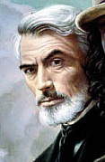
INT. ADMIRAL SAN LAGOS' OFFICE
Vega enters and ADMIRAL OVIEDO SAN LAGOS (65-70) is sitting behind his desk and looks up from his screens at Vega. The older man is tall and only slightly overweight. He has medium length white hair and a beard and moustache still peppered with some darker hairs. He's old, but still in good shape.
Oveido gestures to a chair in front of his desk.
Vega walks over to the desk but remains standing.
OVIEDO
Take a seat, Captain Vega.
VeGA
With respect, I'm kind of tired of sitting.
Oviedo glares at Vega, but Vega remains defiant, standing at ease.

OVIEDO
(with resignation)
Your prerogative.
Oveido looks down at some information on some holographic "sheets" (HoloPADDs) he has arrayed on his desk. He sifts through them and picks up the disk-shaped projector for them and stands up. He walks around the desk toward Vega.
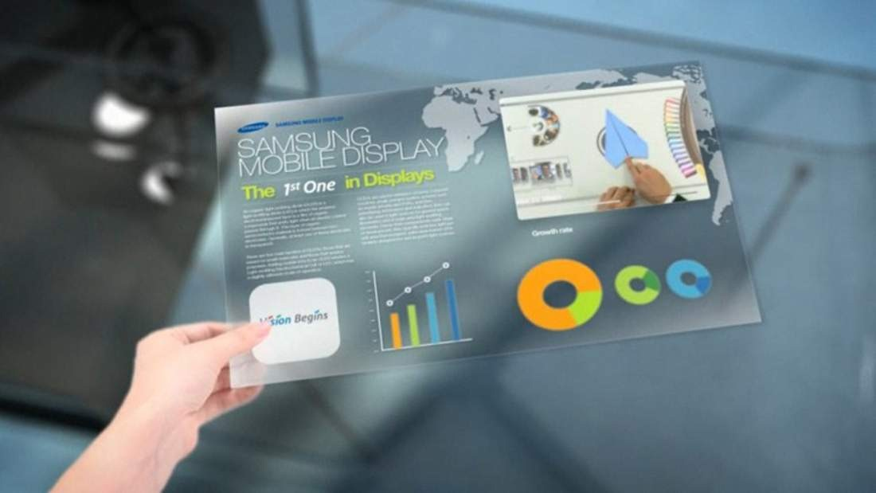
Oviedo looks at Vega as if to speak, but Vega speaks first.
VEGA
Look, whatever I did - it wasn't me!
OVIEDO
(amused)
Oh?
VEGA
Well, there was this shapeshifter on Gamma Hydra IV and-
OVIEDO
It was a changeling, and it was Gamma Hydra II.
Vega and Oviedo both smile. Oviedo sticks out his hand and Vega takes it. The two shake hands and Oviedo pats him on the back warmly.
OVIEDO (CONT'D)
Good to see you again, Sol. It's been too long.
vega
Ten years?
OVIEDO
No, couldn't be... though you certainly don't look like the wet-behind-the-ears Tac Officer I remember.

vega
(falsely)
Well, you haven't aged a day, sir.
OVIEDO
Hah!
They share a laugh and Oviedo steps back and walks to his desk.
OVIEDO (CONT'D)
In any case, it's been much too long. How are things on the Horizon?
Vega responds with obviously qualified enthusiasm.
vega
Can't complain.
OVIEDO
Oh really? That's not what your record says.
He brings one of the sheets of holographic info to the front.
Vega points at the sheets like they're a disease.
VEGA
Those are full of lies and biased-
OVIEDO
"Captain Vega continues to harass Starfleet Command demanding special assignments."
VEGA
They had me patrolling the Argus Sector! An uninhabited sector!
OVIEDO
"Captain Vega has repeatedly questioned the wisdom of his superior officers."
VEGA
Have you met Commodore Birch?
OVIEDO
"Captain Vega shows a pattern of disregard for standard operating procedure, preferring to make up his own rules and trust his 'instincts'."
VEGA
Who said that?!
OVIEDO
It's your psych eval.
VEGA
Okay, well. That part is true.
Oviedo smiles, shaking his head as he puts the HoloPADD down and deactivates it.
OVIEDO
Captain Vega... how'd you like to get away from it all?
Vega looks skeptical.
VEGA
Court-martial or exile?
OVIEDO
A mission, Sol.
Vega is surprised.
VEGA
(curiosity piqued)
Where to...?
Oviedo breaks out in a large grin, this is the moment he's been waiting for. He hits another HoloPADD and it projects the image of a large galaxy.
OVIEDO
Andromeda.
Vega is dumbfounded. He just stares at the galaxy. Then at Oviedo, who just smiles at him, loving every second of it.
VEGA
You're joking.
OVIEDO
Dead serious.
VEGA
The Andromeda Expedition? Me?
OVIEDO
If you want it. And maybe even if you don't.
Vega is still shocked, just doesn't understand how this happened.
VEGA
Was there a clerical error, or-
Oviedo turns serious now.
OVIEDO
Sol. This is not an ordinary mission. The crew that takes this voyage is going to be on their own, out there in unknown territory. Having to fend for themselves with no support from Starfleet. They're going to need a Captain who can think on his feet, trust his instincts and bring them home safe.
Vega nods, staring at the hologram of the galaxy, thinking.
Oviedo goes to the window and looks up out at the night sky.
OVIEDO (CONT'D)
Our Galaxy today is a different galaxy than when I was a young officer, Sol. There was a wonder to it all. We were pioneers, every new encounter was a first. A discovery.
Vega looks at Oviedo, listening.
Oviedo sighs and turns to Vega with a rueful smile.
OVIEDO (CONT'D)
(with resignation)
Starfleet is just a glorified police force nowadays.
(dismissively)
Ensuring trade routes, escorting ambassadors and dignitaries, settling regional disputes.
vega
That's not entirely true, sir.
OVIEDO
No, no... there are still some discoveries to be made and some good, old-fashioned adventure to be had!
He grins and steps back toward the desk.
vega
If you know where to look.
OVIEDO
(pointedly)
And you complain loudly enough.
Vega smiles, admitting the point.
Oviedo turns off the galaxy hologram and smiles. He knows Vega is right for the mission.

Int. StaRFLEET HQ - corridor
Oviedo and Vega are walking together down a corridor.
VEGA
So let me get this right. You're offering me probably our most historic mission, in another galaxy, completely on my own without the oversight of Starfleet.
OVIEDO
(sighs)
Yep.
VEGA
(likes it so far)
What's the catch?
OVIEDO
Sol... you've always shown great potential. I knew back on the Pegasus that someday you'd make a great Captain... Hell, I knew at the Academy.
Vega is waiting for the other shoe to drop, doesn't like where this is going. Senses a big "but" coming.
OVIEDO (CONT'D)
I'm not saying it was easy, I had to fight for you. You've stepped on a lot of toes, ruffled a lot of feathers. But I knew you were the right captain for the job.
VeGA
Thanks, Admiral, but-
Oviedo stops at a door.
OVIEDO
But, honestly, the thing that sealed the deal was, well... You were requested. Personally.
Vega looks confused.
VEGA
By who?
Oviedo presses a button by the door and the doors open. The sign by the door reads:
ASTROMETRICS LAB
Oviedo gestures for Vega to go in first. Vega looks at him questioningly, then steps in.
Int. StARFLEET HQ - astrometrics lab
Vega walks into the darkened room and looks around. Looking up through the clear dome he can see the bright stars in the night sky. Monitors line the walls of the room, all showing different stars and planets and astronomical data.
Squinting, Vega sees someone step forward into the light.
It's COLE WESTON (35). He is tall, handsome and of average build. He has short, combed-back dirty blonde hair, clear blue eyes and has a scruffy beard giving him a somewhat rugged look. He is dressed casually and looks more like an archeologist than an officer.
Cole smiles at Vega.
Vega's eyes go wide in recognition.
VeGA
Cole?!
He goes to Cole and the two shake hands and hug with warm camaraderie.
VEGA (CONT'D)
(grandly)
Cole Weston, The Third! "The Great Explorer"!
Cole
(with equal sarcasm)
Solon Francis Vega, renegade Captain and scourge of the Alpha Quadrant.
OVIEDO
"Francis"?!
VeGA
(unconvincingly)
Damn lies!
(to Cole)
How the Hell are you?
Cole
I'm good Sol, it's great to see you again.
VEGA
I should have known you'd get yourself wrapped up in this crazy mission.
Cole
I'll take that as a compliment.
VEGA
What have you been up to? Last time I saw you, you were lost in the Gamma Quadrant looking for some planet that didn't exist.
COLE
I found it.
Vega smiles.
VEGA
I figured you would.
Oviedo comes over and joins the two old friends.
OVIEDO
Cole's heading up the civilian side of the expedition.
VEGA
Civilian?
Cole looks at Oviedo knowingly, doesn't want to have to be the one to have to explain it.
OVIEDO
This is a historic mission, Sol. The entire Federation has a stake in it. This is bigger than Starfleet.
Vega looks at Cole, then back at Oviedo, trying to figure out where this is heading.
OVIEDO (CONT'D)
You know that catch you asked about?
Vega is starting to look wary now.
OVIEDO (CONT'D)
This mission is a joint venture between Starfleet and the major member planets of the Federation. The top civilian specialists from all over the galaxy are joining the mission.
VeGA
A science team?
Vega looks at Cole.

VegA (CONT'D)
(jokingly)
What's that have to do with Cole? He's just a Starfleet dropout with a thing for planet hopping.
Cole smiles at the gibe.
Cole
(good natured comeback)
I seem to recall one of us was top of their class at the Academy.
Vega looks at Oviedo jerks his thumb at Cole.
VeGA
Teacher's pet.
Oviedo smiles at seeing his two former junior officers go at it again.
OVIEDO
All I know is I lost the finest helmsman I ever had when you left Starfleet, Mr. Weston.
Cole
Just had other places I wanted to be, Sir.
Oviedo nods, he understands Cole's desire to see the Galaxy.
ovIEDo
(to Vega)
Cole, here, has logged more first contacts than any Captain in the fleet.
Vega is impressed.
VeGA
(with honest appreciation)
I don't doubt it!
Oviedo leaves the two standing side-by-side by the large center console and walks around to stand on the other side of it.
OVIEDO
Here's how it is, gentlemen. The Federation wants this to be an inclusive mission of discovery and exploration. We don't want to make an overly militaristic first impression. Lord knows we've made that mistake before.
Vega and Cole exchange knowing glances.
OVIEDO (CONT'D)
To that end, this mission is under civilian direction and Starfleet is supplying the ship.
Vega looks surprised at this.
OVIEDO (CONT'D)
(indicating Cole)
Mr. Weston is in charge of the itinerary - where to look for planets, life. He'll direct the civilian specialists and handle any first contacts.
(indicating Vega)
Captain Vega commands the ship and its crew, has veto power on any mission if he deems it unsafe and is in charge should hostilities or other threats to the ship become known.
Vega considers this.
Cole looks at him, trying to see how he's going to react. He looks at Oviedo and the two share a worried look for a moment.
VeGA
(nodding)
Makes sense. If we're going over there, let's do it right. Bring the best and brightest. Why limit ourselves to Starfleet?
Oviedo looks relieved.
OVIEDO
I'm glad you see it that way, Captain. And I honestly couldn't think of two better people for the job.
Vega smiles at this.
VEGA
I know of at least one Captain who'd disagree with you!
Oviedo waves that off.
OVIEDO
Cole. Show him.
Vega's brow furrows. He looks back and forth at Cole and Oviedo, wondering what great secret he's not been let in on.
Cole steps up to center console and looks up into the night sky through the clear dome.

cole
This isn't just another exploratory mission, Sol. This is...
Cole is overcome with a sense of awe and wonder.
Cole (CONT'D)
History. The next step.
Vega isn't sure how to respond. He knows this already. He isn't sure why Cole is being so mysterious.
VEGA
I know. Everyone in Starfleet knows. The first expedition to explore another galaxy.
cole
Everyone in Starfleet thinks they know what this mission is about.
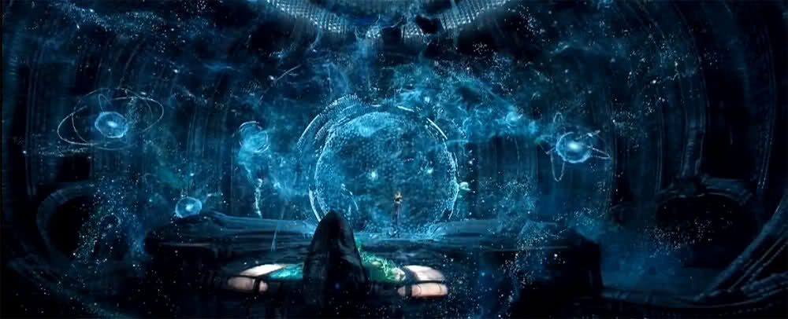
Cole hits a control the center console and the holographic display activates, filling up the majority of the room above them a 3D image of the Andromeda galaxy. Vega steps forward to take a closer look.
Cole turns to Vega, a thrill in his expression.
cole (CONT'D)
They're wrong.
Vega is confused, but intrigued. Oviedo sits back and enjoys it.
On the display, telemetry data appears, analyzed across various spectra.
Vega
Telemetry? From Andromeda?
Cole nods.
vega (CONT'D)
Brought back by the probes.
Cole looks at Vega.
cole
No, Cole. Sent to us. From Andromeda.
Now Vega is dumbstruck. He looks again at the data, then at Oviedo.
vega
When...
OVIEDO
20 years ago. Took Starfleet Intelligence 5 years to decode it.
vega
What does it say?
Cole hits a control and Vega sees the message translated (off-screen).
vega (CONT'D)
This is... is this for real?!
cole
We have no reason to believe otherwise.
Vega steps back trying to process this.
vega
Who...
Cole doesn't answer, enjoying watching Vega work it out on his own.
vega (CONT'D)
How...
(to Oviedo)
Did we reply? Have there been any more messages?
OVIEDO
None. We couldn't reply through normal subspace, the distance is too great. Two years ago we were able to send through the first probe with our response. But there was no reply. We've sent over 20 deep space probes through… but we’ve gotten back not one message, not one sign of intelligent life on the other end.
Vega is baffled. But his curiosity is piqued unbearably.
vega
Who... or what...?
cole
That's what we're going to find out, Sol.
Vega nods absentmindedly, overwhelmed by it all. He shakes his head and smiles at Cole, who's beaming with anticipation at the mission.
OVIEDO
Congratulations, gentlemen. You're going into the history books on this one.
Oviedo offers a congratulatory hand to Vega.
Vega is thrilled; he strides over to Oviedo and accepts his handshake vigorously.
Cole walks up and accepts a handshake from Oviedo too.
cole
You don't know how much this means to me-
Oviedo puts a hand on his shoulder.
OVIEDO
Cole. I know what it means to you.
cole
(earnestly)
Thank you.
The two shake for another moment. It's clear Oviedo is proud of Cole and Vega, like a father is of his grown son when he surpasses the father. Proud, and a little jealous.
Ext. StarFLEET HQ - night
Vega and Cole are walking away from Starfleet HQ. The stars can be seen reflected in San Francisco Bay as they walk.
Vega
Can you believe it? A couple of Academy delinquents like us - the first to go to Andromeda?!
Cole smiles, but something is on his mind.
ColE
Sol... are you sure you're okay with this?
Vega looks pensive for a moment, then abruptly turns on the charm.

VegA
Sure, why wouldn't I be?
COLE
It's still your ship, your command-
Vega interrupts Cole's appeasement, putting his arm around him.
VEGA
My ship, your mission. Who cares? We're back in action at last!
Cole smiles, happy that Vega is taking it well.
VeGA (CONT'D)
To be honest, I always figured I'd end up working for you someday anyway.
He steps in front of Cole, walking backwards, making a grand gesture.
VEGA (CONT'D)
As my people say: "to the stars our fates belong, may they never steer us wrong"!
Cole smiles suspiciously at him.
Cole
(skeptically)
I've never heard you say that before.
VEGA
Yeah, but it sounded good.
(BEAT)
Come on, the old crew's down at Boothby's, they'll want to say their "good riddances"!
Vega pats him on the back and the two walk off.
Cole, smiling, looks out over the bay of stars, his mind racing at the wonders awaiting him in Andromeda.
FADE OUT.

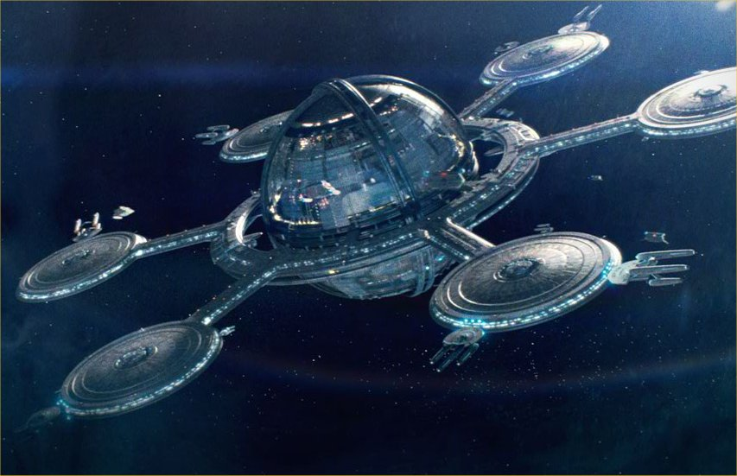
EXT. SpACE
A shuttle flies by and the scene pans to reveal Deep Space B-7, an isolated space station at the far reaches of the Galaxy.
TITLE OVER:
Deep Space B-7
Beta Quadrant
Ext. DEEP SPACE B-7
The Starfleet shuttle comes in for a landing in one of the station's docking bays.
Int. DEEP SPACE B-7 - docking bay
The shuttle lands and crew stream out.
One of them is VIIN (20), a young blonde half-Romulan woman. Her hair is cut in a sort of modern pixie: short in the back and long in front. She is short and thin. She wears the uniform of a Starfleet ensign and is carrying a sack.
Viin looks around anxiously. She looks down at a HoloPADD she is carrying then looks around even more anxiously.
The crowd around her is streaming past her, brushing against her and jarring her a bit. She looks lost.
She starts to head off in one direction, then suddenly changes directions and bolts in the opposite direction.
She bumps right into Admiral Oviedo San Lagos, who is in civilian clothing and was carrying a raktajino, which is now all over his jacket.
Viin is surprised and immediately apologetic.
VIIN
Oh! I'm so sorry!
OVIEDO
You really should look where you're-
Viin is desperately trying to clean the spilled drink off Oviedo's jacket with her own sleeve. It's only making it worse, but she doesn't notice.
VIIN
I'm such a kobetz! I'm just - it's just that I'm supposed to report for duty and my shuttle was late and I don't even know-
Oviedo takes her gently by the arms and stops her fruitless attempts to clean up the mess.
OVIEDO
Slow down, slow down.
She looks up at his face for the first time, but still seems jittery and nervous.
OVIEDO (CONT'D)
Maybe I can help, where are you trying to go?
VIIN
Oh, I'm supposed to report to...
(looks at her HoloPADD)
An "Admiral San Lagos".
(realizing the time)
Dammit! I was supposed to be there 10 minutes ago!
OVIEDO
San Lagos, hunh? Well, you're in luck. I haven't been on the station long, but I think I can point you in the right direction.
Oviedo uses her HoloPADD to bring up the station directory and has it show her the route to his office.
Viin is embarrassed she didn't think of that herself.
VIIN
Oh, wow, thank you - Thank You!!
Viin starts to back off. Oviedo calls to her loudly.
OVIEDO
Better hurry up, I hear that Admiral's a real hard ass!
Viin panics and turns to run, bumping into a couple more people as she runs off.
Oviedo smiles after her, amused. He looks down at himself and his drink and then drops the mostly empty cup into a passing recycling bot.
Recycling bot
(bleeps)
Thank you. For. Recycling.
(bleeps)
Int. DEEP SPACE B-7 - Antiques shop
LT. NICOLAS DA SILVA BATISTA (25) is a lanky, younger-looking Starfleet junior officer. He's of average height, has short, wavy dark hair and has a face that, while not traditionally handsome, is very expressive.
He is checking out some artifacts on the shelves of an antiques shop. Outside the shop, he sees Viin run past, causing a minor commotion. He turns his attention back to the artifacts and picks up one in particular.
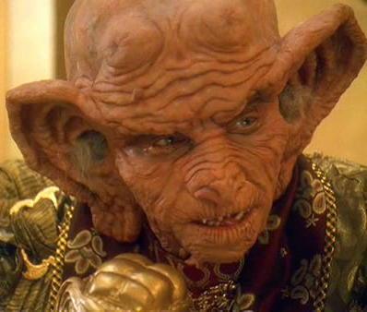
Batista turns it over in his hands a few times, running his fingers along the runic symbols inscribed along the length of it.
FITCH (60) - an older Ferengi shopkeeper, sidles up beside Batista unnoticed and speaks, startling Batista.
FITCH
(going for the "soft sell")
It's one of a kind, you know. Recovered from the ruins of Galidan Prime.
Batista looks intrigued.
FITCH (CONT'D)
The archeologist who sold it to me said it's over ten thousand years old...
Batista is studying it closely. The Ferengi is anxious to make the sale.
Batista
(distractedly)
Isn't Galidan Prime quarantined?
The Ferengi doesn't appear to have known this, but rolls with it.
FITCH
Yes!
(with mock somberness)
The poor bastard died a week later.
(pauses appropriately)
All of which makes it so much the rarer! And more valuable!
Batista seems impressed.

FITCH (CONT'D)
Of course, I'm but a humble purveyor of rarities and curiosities. You seem like an astute student of history, am I right?
BATISTA
Well...
FITCH
Tell you what. Because I have a feeling - call it an intuition - that you just might be the one to decode this enigma, I'll let you have it for, say... 10 bars.
BATISTA
Really? 10 bars?
FITCH
Nine. Only because I like your face.
BATISTA
Wow, that's very generous of you-
FITCH
(disingenuously)
Of course-
The Ferengi heads to his register and tries to take the artifact from Batista, but Batista pulls it close to him and inspects the runes more carefully.
BATISTA
The only thing is... these runes are in a form of proto-Ktarian, but they clearly read:
(looks closely at them)
"Made on Ferenginar".
The Ferengi's flattering facade melts away.
FITCH
(directly)
What's your point.
Batista offers the artifact back to the Ferengi.
BATISTA
It's not worth the synthiplast it's made from.
Batista smiles and the Ferengi snatches it from his hands.
The sneer fades he sees a rough-looking alien come in: KREEG - a Klingon with a large scar on his forehead. Batista turns to see him as the shopkeeper backs up in fear.
FITCH
(nervously)
Kreeg, now... I don't want to have to call security-
The shopkeeper is about to reach for a panel, but the Klingon smashes it.
KREEG (in Klingon)
(sarcastically)
Oops.
The Klingon leers at the shopkeeper threateningly and emits a guttural sound that seems to be a laugh of some sort.
Batista looks at the Klingon anxiously, trying to figure out whether to help or run and send help.
Kreeg walks around behind the counter to where the Ferengi is standing, "accidentally" smashing a few more items along the way.
Fitch
Wait, please! Tell Sirius he'll have his money!
KREEG (in KLINGON)
20 bars, Fitch! And that's the discount rate!
FITCH
I just don't have it right now!
(to Batista, accusingly)
Sales have been slow, there's not a bar in the till, I swear! See?
He opens his register and it's completely bare.
Kreeg slams his fist down on the counter in anger, shaking all the wares on the shelves.
Kreeg (IN KLINGON)
You Ferengi think you're-
Batista steps in front of the Klingon and picks up the fake artifact. Kreeg stops in mid-sentence and looks down at Batista, enraged and appalled that a puny human would interfere in this way.
Batista
Excuse me, I was here first...
(to Fitch)
How much was this again?
Kreeg looks at Batista in confusion and disbelief.
Fitch looks shocked and confused, too - speechless. He looks at Batista like he's crazy.
BATISTA (CONT'D)
20 bars, wasn't it?
(to Kreeg)
Seems like a bargain!
Batista begins to dig around in his shoulder bag and presents 20 bars of gold-pressed latinum.
Kreeg's eyes widen in surprise and he grabs the latinum from Batista's hand. He looks at them, biting them to make sure they're real. He looks back at Batista.
Batista simply smiles at him.
BATISTA (CONT'D)
Well, good doing business with you, see you-
Kreeg pulls at Batista's shoulder bag and Batista drops it, spilling the contents all over the floor. The Klingon bends down to rifle through it, looking for more bars of latinum.
Batista and Fitch exchange a quick glance and bolt for the exit, but Kreeg cuts them off, dropping the empty shoulder bag and pocketing a few more bars.
KREEG
(continuing)
Were you trying to make me look STUPID, Human?!
Batista
(nervously babbling)
Oh, no, I think you're managing that just fine on your own.
Fitch glares at Batista like he must have a death wish.
KREEG
WHAT?!!!
(to Fitch, in Klingonese)
I'm going to teach this petaQ a lesson in respect!
Batista begins to panic and blather.
BATISTA
Whoa, whoa, I really wouldn't bother-
Kreeg looks at Batista, realizing he understands Klingonese.
KREEG (IN KLINGON)
Why not?!
Batista
(babbling)
I'm a slow learner, really... and, well, I bleed really easily, and, uh, it would really be a mess, you could slip, maybe fall and hurt yourself... and I've been known to scream really, really loud, so...
Fitch shakes his head.
KREEG
(screams)
RRAAAGGH!!!
Kreeg grabs Batista by the collar and winds up for a punch. Batista covers his face and squeezes his eyes tight. Suddenly, a hand reaches for him and yanks him away, out of Kreeg's reach.
Standing before Kreeg is LT. COMMANDER QORA (25) - a tall, imposing, strong-looking, green-skinned Orion woman wearing a Starfleet security uniform. She has thin, raised ridges on her cheek bones, chin and on the bridge of her nose. Her wavy dark green hair is pulled back in a high, loose ponytail and the sides of her head are buzzed close. She sets down Batista with ease, behind her.
Kreeg is surprised. Fitch takes advantage of the distraction to slip away behind the register counter with Batista.
The Klingon rushes forward but Qora spins and slams him face-first into the wall. This seems to only anger the Klingon. He turns around and charges her again, but she deftly sidesteps him and twists him so that he flies through the window.
Fitch flinches, not out of empathy for Kreeg, but for the lost revenue in his destroyed merchandise and the projected cost of fixing the window.
EXT. DEEP SPACE B-7 - anTIQUES SHOP
The Klingon flies through the shop window. Startled passersby react and scatter. One of them runs up to a counter in another shop.
PASSERBY
(to the shop owner)
Call security, there's a fight!
The shop owner runs back into his store.
Kreeg gets up and wipes blood from his mouth. The Klingon smiles, seeing a good fight on his hands. He climbs back through the window into the shop.
INT. DEEP SPACE B-7 - anTIQUES SHOP
Batista and Fitch peek over the counter to watch the fight.
KREEG
(derisively)
Qa'be'Hom!
Batista understands the curse.
BATISTA
(to Fitch)
That wasn't polite at all!
QORA
(mockingly)
Funny, I thought Klingons fought with fists, not words.
The Klingon laughs and lunges at Qora.
Qora is able to dodge the charge and kick the Klingon in the butt, sending him reeling off-balance. The Klingon slams into the counter which jars open a hidden compartment under the register. Scores of bars of gold-pressed latinum are inside, some spilling out onto the floor.
Fitch desperately goes to catch them and shove them back in.
Batista gives the Ferengi a disappointed look, but Fitch only pauses long enough to shoot him a dismissive glance and continues picking up the money.
The Klingon gets enraged and stands up. He growls and draws a D'k tahg (Klingon dagger).
QORA (CONT'D)
(continuing)
That's a warrior's weapon, are you sure you know how to use it?
KREEG
ENOUGH!! I'm going to gut you like a to'baj, woman!
Kreeg charges at Qora with the knife. She side-steps more carefully this time, but Kreeg spins and slashes at her tunic, cutting though it and leaving a wide bloody gash on her abdomen. A small amount of viscous, green blood oozes out.
Batista and Fitch are watching again, worried now.
Kreeg takes advantage of the moment and stabs Qora in the ribs with the dagger. Qora grunts in pain and it looks as though Kreeg has won.
But to Kreeg's amazement, Qora grabs Kreeg's hand and twists his thumb painfully. Kreeg howls in pain and Qora kicks him away, hurling him against a back wall. She staggers a bit, the dagger still stuck in her ribs.
The Klingon, enraged now, turns away and crouches down. He reaches into his boot and draws a hidden disruptor.
Qora quickly takes off her large gold bracelet - with a soft beep it morphs into a glowing plasma whip and with a quick flick of the wrist Kreeg's forearm is sliced clean off by the whip - the wound is instantly cauterized.
Kreeg is shocked and looks down at his forearm, then at his hand on the ground, still holding the disruptor.
Kreeg screams in pain and drops to the floor holding his arm stump.
Batista is shocked. Fitch pumps his fist in silent victory.
Qora walks up to Kreeg and nerve pinches him to knock him out. Qora pulls the dagger out from between her ribs, wincing, keeping a hand over the wound.
QORA
(teeth gritted in pain)
Security to Sickbay-
vega (O.S.)
That won't be necessary, Commander.
Qora, Batista and Fitch turn to see Vega standing in the doorway. Cole is there, too, behind Vega. Medics and a security team are coming in behind them.
Qora sees Vega's rank and snaps to attention.
QORA
Sir!
VeGA
At ease, Commander.
Vega walks in and looks at the mess.
veGA (CONT'D)
(continuing; to Fitch)
Unsatisfied customer?
FITCH
Nothing I couldn't handle.
(to Qora)
Though there is the small matter of compensation for damages to my establishment...
Qora glares at him in disgust.

QORA
Bill me.
Batista recognizes Cole.
Batista
Cole Weston? I was on my way to see you... Nic Batista?
cole
(recognizing the name from the roster)
Yes, Lt. Batista, xenolinguistics. You were one of the first crew Starfleet assigned to this mission.
Batista
Yes, well, more like "drafted"... I'm not really Starfleet.
The two are distracted by medics carrying the Klingon away with his severed arm.
Medic
(to Vega)
He's lucky, sir, the cut's clean. We should be able to reattach the arm easily.
QoRA
(sarcastically)
Oh, good.
A medic brings a dermal regenerator over to Qora's abdomen to heal her cut, but is surprised to see it already self-mending. Fibers of green skin have already grown across the wound and are pulling it back together like organic stitches. He lifts her hand from her stab wound and sees even it is starting to heal. He looks up at her in amazement, then proceeds to repair the damage with his medical regenerator.
Batista is looking at Qora in awe, immediately infatuated. He approaches her as the medic works.
BATISTA
(to Qora, gushing)
Can I just say: you were amazing.
Qora hadn't really noticed Batista before. She looks down at him, not sure what to make of him. She's a bit off-put by the compliment.
QORA
(insincerely)
Thanks.

cole
(to both)
Why didn't you call station security?
QORA
I was the closest security officer. And the situation called for immediate action.
Batista nods in agreement vigorously.
Cole looks at her plasma whip, now deactivated.
Cole
That polyweapon isn't exactly Starfleet standard issue.
QORA
It comes in handy. No phasers are allowed on the station.
She morphs it back into a bracelet and snaps it back on.
Batista
(approvingly)
It's very flattering.
Qora growls at him and he flinches, but smiles back at her.
Vega steps forward. The medic has finished and walks off.
vega
Cole, I'd like you to meet Lt. Commander Qora...
Qora and Cole shake hands.
Vega (CONT'D)
(smiling)
Our new Chief of Security.
Cole and Qora both look at Vega in surprise. Vega is grinning at Cole's expression.
Batista
(grinning broadly)
I feel safer already!
Qora rolls her eyes.
Ext. Starfleet transport
A Starfleet transport vessel approaches Deep Space B-7.

Int. StarFLEET TRANSPORT
LEXIA (30) is at a window seat looking out at Deep Space B-7. She is a Deltan of average height, slim build, light skin, dark eyes and is bald. She wears a flattering, comfortable blue outfit.
DR. FIRELA ZAN JOLI (40) is seated next to Lexia. She is full-figured, slightly taller than average and has light skin, long red hair in an updo and blue eyes.
Joli leans over and looks out the window, too.
Lexia looks Joli over. Joli is a voluptuous woman and covered from neck to toe in tight clothing. She is even wearing gloves.
Joli notices Lexia looking her over and smiles at her politely.
LEXIA
I'm sorry, I don't mean to be rude.
Dr. Joli
Oh, no, it's quite all right.
LEXIA
It's just that... you're a Suvani, aren't you?
DR. JOLI
(smiling, a bit impressed)
Yes, I am!
LEXIA
Fascinating! I've never met a Suvani in person before.
Lexia offers her hand. Joli takes it and clasps it warmly.
LEXIA (CONT'D)
Oh, I'm sorry, that sounded bad. You must feel like you're under a microscope. I'm Lexia.
Dr. JOLI
Nice to meet you, Lexia. I'm Firela.
They shake warmly and both return to their own activities - Joli reading from a HoloPADD and Lexia pretending to read her own. But Lexia is clearly bursting at the seams with questions.
LEXIA
Okay, I have to ask - I may never get this chance again...
Joli smiles with polite patience.
LEXIA (CONT'D)
What's it like?
DR. JOLI
Excuse me?
LEXIA
Well... no men...
Dr. Joli knows what Lexia is getting at but decides to play it a bit coy.
DR. JOLI
Oh, we get along just fine.
LEXIA
No, sorry, I mean... Asexual reproduction... I know parthenogenesis is not uncommon in-
Lexia sees Joli's expression of amusement and catches herself.
LEXIA (CONT'D)
I'm sorry, that was terribly rude. That's way too personal, I shouldn't have-
DR. JOLI
No, no... I'm a doctor, I'm not easily embarrassed. It's quite all right.
Lexia is relieved. But Joli doesn't answer, she just goes back to reading on her HoloPADD. Lexia can't stand it anymore. She leans over to Joli.
LEXIA
(whispers)
It's just that-
DR. JOLI
(interrupting)
There are several excellent instructional holoprograms on the matter if you'd like me to recommend one.
Now Lexia is totally embarrassed.
LEXIA
Wha-what? No... no! That's not what I-
Joli laughs warmly and reassures Lexia.
Dr. JOLI
I'm just teasing. It's actually not all that mysterious. We're fairly similar to Humans, anatomically. We make love and get pregnant and give birth much like a sexually dimorphous species, only we-
LEXIA
But how?
Joli finally gets what she's asking and smiles broadly at her.
DR. JOLI
Oh... Well, it involves a lot of touching-
LEXIA
(remembering her studies)
Right, to transfer genetic material through skin contact.
(excitedly, like figuring out a puzzle)
Is that why you're always covered up?
Joli is pleasantly amused at Lexia's enthusiastic curiosity.
DR. JOLI
Around other species, yes.
LEXIA
(without thinking)
And is it true that you do it in groups?
DR. JOLI
(laughs)
You are quite curious aren't you?
Lexia is suddenly very apologetic.
LEXIA
Oh, I'm sorry. I get carried away sometimes. It's just my nature - I'm a xenobiologist, first and foremost.
DR. JOLI
Oh, I know.
Lexia is surprised.
LEXIA
You do?
DR. JOLI
Yes, I read your medical file.
Dr. Joli holds up her HoloPADD. It's displaying Lexia's file. Lexia is totally flabbergasted now.
Dr. Joli offers her hand in introduction now.
DR. JOLI (CONT'D)
Doctor Firela Zan Joli. Head of Health and Wellness for the Andromeda Expedition.
LEXIA
Oh! That's quite a mouthful...
DR. JOLI
(smiles)
It's a new position. Since we'll be operating without a support structure initially, I'm responsible for more than just medical needs. I'll also be overseeing the crew's fitness, nutrition, mental health, recreation and morale.
Lexia is speechless - that's a lot of responsibilities. She just gawks at Dr. Joli.
DR. JOLI (CONT'D)
And you're our Sciences Lead - quite an accomplished xenobiologist to get this assignment, I imagine!
Lexia is humbled by the compliment.
LEXIA
(blushing)
I guess I'm the one under the microscope now. Fair enough.
DR. JOLI
Don't worry, I won't tell anyone about your...
(looking down, raising her eyebrows)
condition.
Lexia is confused and taken aback. She looks down at herself trying to imagine what Joli is talking about. She sees the mischievous sparkle in Joli's eyes and both women laugh.
Dr. JOLI (CONT'D)
And: yes.
LEXIa
(confused)
Hmm?
DR. JOLI
We do.
(leans in, whispers)
And it's mind-blowing.
Lexia smiles in surprise and the two women laugh again.
A steward approaches them.
Steward
We'll be docking in a few minutes.
Joli nods and Lexia looks out the window. She sees the Spacefold Gate being built nearby.
LEXIA
There it is...
Joli looks out the window at it.
JolI
Quite a miracle of science.
LEXIA
Just imagine what we'll find on the other side!
JOLI
(dryly)
Oh, I can imagine.
Lexia looks at her a bit confused.
LEXIA
You don't sound too thrilled with the idea...
Joli smiles a bit sadly, taking a moment to collect her thoughts.
JOLI
I suppose... I'm not sure we've been the best stewards of our own galaxy. Do we really deserve the responsibility for another?
Lexia is speechless. She'd never considered that, having been solely focused on the excitement of discovery. She looks back out at the Gate.
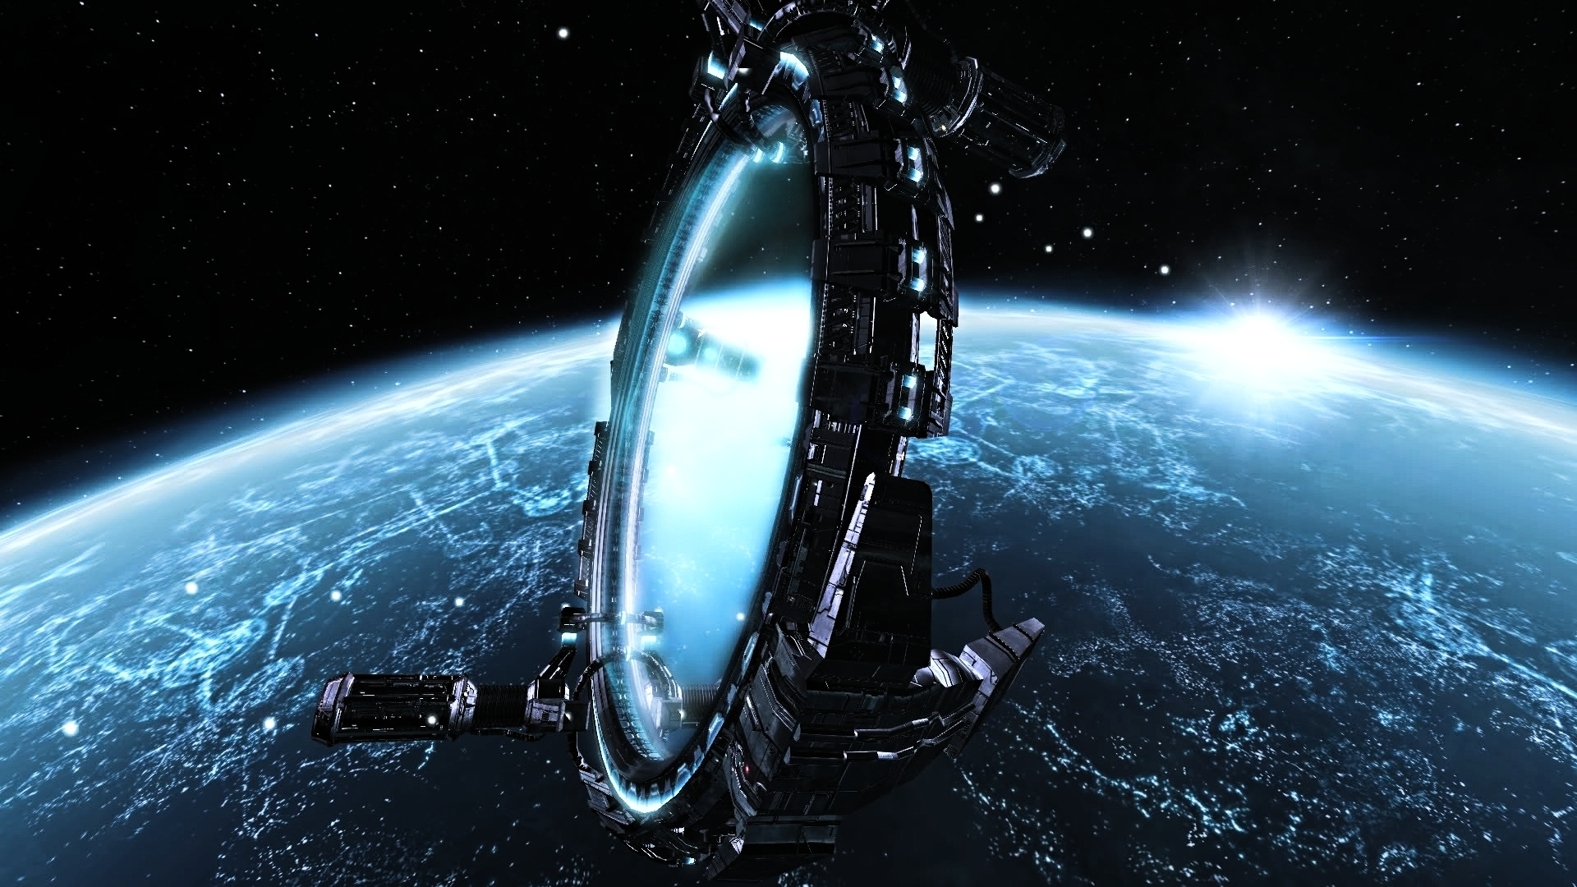
Ext. spacEFOLD GATE
The Spacefold Gate hangs in space several hundred meters from the space station. Several technicians in jet-propelled suits zip around the frame of the Gate. The Starfleet Transport is just a speck at this distance.

Int. DEEP SPACE B-7 - docKING BAY
The Starfleet transport comes in for a landing. Vega, Cole and Qora are waiting. They are startled when the transport drops a bit too quickly and hits the deck ground a bit violently.
ColE
(to Vega)
Don't tell me: our new helmsman.
Vega smiles good-naturedly in response.
They walk up to the transport's hatch as it opens and watch the passengers disembark down a steep ramp.
Lexia appears in the doorway and looks around. She sees Cole and her face lights up in a broad smile.
LeXIA
Cole!
Cole somewhat uncomfortably smiles back. Vega watches them expectantly.
Dr. Joli comes out and sees Cole, Vega and Qora. She smiles at them as she comes down the ramp. She stumbles a bit and falls, but Qora moves quickly to catch her.
Joli is surprised by this and looks up at Qora. She's grateful and impressed by Qora's speed and strength.
JOLI
Thank you! It's these rough shuttle rides - they leave me a bit disoriented.
Qora looks down at her and seems entranced. She simply holds Joli in her arms while Cole, Vega and Lexia watch.
Joli is looking at Qora quizzically, trying to figure out why the tall woman is still holding her. Joli looks down and sees that her bare skin is exposed at the shoulder, as her arm sleeve slid down while being caught. Since Qora is holding her shoulder, their bare skin is directly touching. Joli sighs apologetically.
Joli (CONT'D)
You can... put me down now.
Qora doesn't respond, she just blankly obeys and slowly releases Joli. When Joli leaves her arms, Qora seems to gradually come back to her senses, like a fog is lifting.
Joli (CONT'D)
(pulling up her sleeve)
I'm sorry, it's my skin. My people have a strong... influence over other species we come into contact with.
Qora looks down at Joli's sleeve, then at her own hands, slowly comprehending.
A medic comes over to Joli as Qora pointedly looks away from Joli, embarrassed by her loss of control.
QORA
... excuse me.
Qora walks off abruptly.
The medic tends to Joli, but she brushes him off in annoyance, she's fine. But she watches Qora leave, regretting that she made her uncomfortable.
Lexia, Cole and Vega turn away from the scene, not wanting to make anyone feel any more self-conscious. There is a moment of awkward silence as nobody seems to know what to say. Vega looks back and forth at Cole and Lexia, sensing something between them.
Vega
(pointing elsewhere)
I'll just...
He slips away without them acknowledging him.
Lexia and Cole start walking towards a turbolift, neither knowing what to say.
COLE
It's good to see you again, Lexi.
LEXIA
(smiles)
You look well, too, Cole.
cole
That's... not what I meant.
Lexia looks up into Cole's intent gaze. She knows what he means. Cole stops in front of the turbolift with her.
cole (CONT'D)
Lexi... when I saw they picked you for the mission... Well, I thought you might-
Lexia doesn't want to have this conversation right now. She steps forward causing the turbolift doors to open.
LEXIA
I'd love to catch up, Cole, but it was a long trip out here and I'm in desperate need of a bath.
(stepping, adding)
And I need to check in on my staff!
She smiles at him halfheartedly and the doors close.
Cole takes a step toward the doors, but stops. He looks away, a bit lost in thought. As he takes a step to walk away, the turbolift doors open again behind him. He turns, expecting to see Lexia again.
OVIEDO
Ah, Mr. Weston!
Cole looks up and is surprised to see Vega, Oviedo and an officious looking alien in the turbolift. Oviedo gestures for Cole to come in.
OVIEDO (CONT'D)
Step into my office.
Cole smiles and enters.
Int. DEEP SPACE b-7 - turbolift
The turbolift is large with windows that provide a view out at space and into the interior of the space station as they travel through it.
OVIEDO
Docking Bay 3.
The turbolift begins to move. Oviedo gestures to the alien (FEDERATION ADMINISTRATOR, 45) and introduces Cole to him.
OVIEDO (CONT'D)
Cole Weston, this is Administrator Ferren, he's our Federation liason for the Andromeda Expedition.
Cole holds out a hand and the Administrator smiles in a very practiced way and shakes it, albeit with some subtle distaste.
ColE
An honor to meet you, sir.
Fed admin
The pleasure is all mine, Mr. Weston. I've heard such tall tales about your exploits in the outer arms. You must regale us with them some day.
His friendliness is slick and almost certainly put on.
COLE
Well, it's all in the journals, nothing too exciting-
FED ADMIN
Oh, no need to be humble, Mr. Weston, we all know how you "space cowboys" like to zip around the Galaxy on your grand adventures. Very exciting, if a bit frivolous.
Cole realizes now that the Admin is mocking him. He politely nods and tries to respond diplomatically.
COLE
Well, it's not all fun and games.
FED ADMIN
(smarmily)
MMmm...
The turbolift stops at the Admin's destination. He starts to exit.
FEd ADMIN (CONT'D)
I look forward to witnessing you make history, Mr. Weston.
He stops in the door and looks back at Cole.
FED ADMIN (CONT'D)
And I do hope you find something worth all the considerable time and expense the Federation has invested in your little... adventure.
It's clear this is a veiled threat. The doors slide closed on him and the turbolift continues moving again.
VeGA
(sarcastically)
Nice guy.
OVIEDO
He voted 5 times to defund the expedition.
VEGA
I knew I didn't like him.
They all smile, but Cole can tell something is on Oviedo's mind.
Cole
Admiral... what is it?
Oviedo looks at both of them a bit solemnly. He's not sure he should say what he's thinking, but he relents.
OVIEDO
You should know... this mission is not without controversy. The President almost didn't get approval for this mission. It was a close vote, and she made a lot of enemies.
(sighs)
Some in the Federation... think we shouldn't be squandering our resources just to meddle in the affairs of another galaxy. They think we have enough problems here at home.
Cole and Vega exchange glances. Vega seems to know this already.
Cole
How bad?
Oviedo sighs and steps to the outer window, looking out at the Gate.
OVIEDO
The Federation is... more fragile than most know. There are just too many civilizations with different agendas and long-standing differences pretending to get along since the end of the War. And the Federation Council is too big and slow to enact any real solutions.
Oviedo turns to Cole and Vega.
OVIEDO (CONT'D)
Our analysts think the Federation's only going to hold together for another few years. This mission has to happen now or it may never happen at all.
There's some silence while everyone takes this in.
Vega smiles and tries to change the mood.
VegA
(to Cole)
Well, looks like we're getting out just in time!
Cole raises his eyebrows and shakes his head. He's never enjoyed politics.
The turbolift doors open and Oviedo steps out. Cole and Vega follow him.
Int. Deep SPACE b-7 - docking bay 3
Oviedo steps forward and turns around, holding his arms wide, smiling, happy to change the tone.
OVIEDO
Gentlemen. How'd you like to do a little "sightseeing"?
Oviedo smiles broadly and walks over to Vega. Vega gets his meaning and his face lights up immediately.
Oviedo puts his arm around Vega.
OVIEDO (CONT'D)
Mr. Vega, this is a moment no Captain ever forgets.
The three walk away together.
EXT. DEEP SPACE B-7

A Starfleet shuttle from Deep Space B-7 passes by the Spacefold Gate.
Int. ShuTTLE
Captain Vega, Cole Weston and Admiral San Lagos are in the shuttle. Ensign Viin is at the helm. Oviedo points and Cole and Vega look.
Ext. shuTTLE
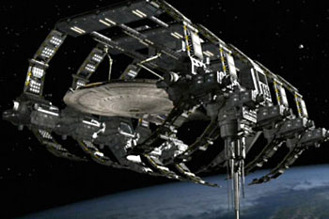
The shuttle approaches a free-floating spacedock. A large ship is inside.
INT. SHUTTLE
Vega and Cole are looking expectantly, Oviedo watches them.
EXT. SPACEDOCK
See the starship. It doesn't look like a battleship, it seems to be built for science and exploration. But it is still a graceful, beautiful ship. Its rounded primary hull houses large bay windows and a central core that runs through its center, surrounded by a large transparent atrium: a botanical garden ready to house countless alien flora and fauna. It has a large forward deflector and two powerful warp nacelles. Its gunmetal gray hull gleams under the spacedock lights.
INT. SHUTTLE
Vega grins like a school kid. Cole sees the new ship for the first time. He is stunned, speechless.
vega
She's a beauty isn't she?
Ext. Spacedock
Several passing "beauty shots" of the ship as the shuttle flies around it.
INTERCUT reactions shots from Vega, Cole, Oviedo and Viin.
The ship's registry number reads "NXA-1701" and bears the name "USS Enterprise".
INT. SHUTTLE
Cole is obviously mesmerized by the new ship.
vega
Perseus Class. Totally new design, fully equipped. Full science labs, and an E.M.E.V. Integrated System AI with HoloTac displays. Phased shielding, self-repairing nanite construction, remote-pilot drones and the latest quantum state replicators. And the first "white hole" singularity drive in the fleet!
COLE
She looks fast.
VEGA
(grins proudly)
Fastest in the fleet. You should have been there for the space trials.
OVIEDO
Be glad you weren't. I think my heart stopped twice.
VEGA
(dismissively, to Cole)
It was just a little shakedown cruise.
Cole ogles the ship in admiration.
cole
(appreciatively)
Enterprise.
Oviedo
It seemed fitting. And it's been far too long.
vega
It's an honor.
Oviedo is proud of the two men. He sees him as sons and brothers.
OVIEDO
And within a year, we'll have two more like her to join you in Andromeda.
Vega puts his hand on Cole's shoulder. Cole smiles.
Cole
I'm glad you're the one taking us there, Sol.
VeGA
You kidding? Wouldn't miss it for the world.

cole
(a bit intimidated)
It's a lot to live up to...
Vega
(with mock criticism)
Don't tell me "The Great Explorer", is getting the jitters from a little jaunt across the Universe?
cole
(as if that makes it seem better)
Well, when you put it like that...
Oviedo understands - this is the moment of truth. Seeing the ship for the first time makes the mission feel real at last.
OVIEDO
Feeling the weight of history, Cole?
cole
(shakes his head)
It's just... this mission... how do I know I am the right man to lead it...
OVIEDO
"He who seizes the right moment, is the right man."
Cole smiles, knowing he walked right into one of Oviedo's pearls of wisdom.
Wryly, Vega dredges up another classic.
vega
And "fortune favors the bold!"
Oviedo chuckles and puts his hand on Cole's shoulder, reassuring him.
OVIEDO
You'll do fine. I have faith in you. I always have.
(pause, somewhat teasingly:)
And if you need something to calm your nerves, I know your new CMO... I could put in a word with her...
cole
(sarcastically)
Thanks.
The shuttle pilot turns around and interjects, surprising all three men.

Viin
Oh, wow, I'm so relieved to hear you're nervous, too! I'm scared out of my mind! But also really excited, too! Know what I mean?
Cole is taken aback. Shuttle pilots are supposed to be seen, not heard - especially in moments like this.
Viin takes her hands off the controls and shows them to Cole, Vega and Oviedo. They're shaking visibly.
Viin (CONT'D)
I've been literally shaking at the thought of piloting the Enterprise to a whole other galaxy! I'm glad I'm not the only one!
Vega sees the shuttle heading directly for the Enterprise hull. He makes a warning motion toward the controls, but she keeps talking.
ViiN (CONT'D)
(to Oviedo)
And, can I say what an honor it is to serve under you, Admiral San Lagos? Your tactics during the Galactic War were just... really inspiring!
Oviedo puffs up a bit at the flattery, looking to Vega and Cole with pride.
OVIEDO
(with false modesty)
Yes, well, that's all ancient history now-
VIIN
Oh, I know - we learned all about it in my Starfleet History class!
Oviedo is off-put by the insinuation that the prime of his life really is history now. Cole and Vega smile.
OVIEDO
(icily)
Eyes back on course, Ensign.
Viin looks forward and casually corrects course, averting a collision with the Enterprise. She glances back at Cole and smiles, shivering her shoulders to share with him how nervous and excited they both must be.
Cole turns away as Viin begins heading for the Enterprise Shuttle Bay. He's mortified, realizing that the shuttle pilot must be an Enterprise crew member. He just exposed his fears and insecurities in front of a very junior officer.
Vega walks over to him.
cole
(under his breath)
She's one of yours, isn't she.
vega
(smiles, nodding)
Ensign Viin, navigator and helmsman.
cole
I'm never going to live this down, am I?
Oviedo has come over and pats Cole on the back.
oviedo
(reassuringly)
Don't worry, Cole. You boys are going to make much bigger mistakes than that before you're done.
Cole and Vega offer expressions of mock gratitude.
Ext. EnterPRISE
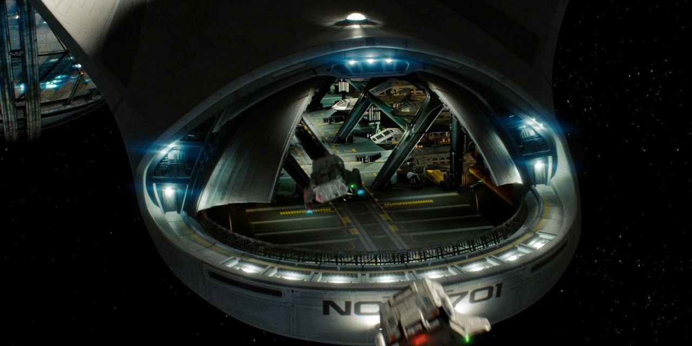
The Shuttle Bay doors open and the shuttle coasts inside.
Int. Enterprise - shuttle bay
As shuttle lands, Security Chief Qora, the officer of the watch, the boatswain's mate and 2 security guards line up by the shuttle hatch.
The shuttle hatch opens and the boatswain's mate blows his whistle. Vega stands in the hatchway.
Vega
(to Qora)
Permission to come aboard?
qora
Permission granted. Welcome aboard, Captain.
vega
Thank you, Commander Qora.
Vega steps out, followed by Cole, Oviedo and Viin. Vega turns and looks at Cole and Oviedo.
Vega (CONT'D)
Look at this, the three of us back together again. Just like old times!
Cole and Oviedo smile. Vega clearly misses the rapport they shared before.
OviEDO
Speaking of which, you still owe me a rematch.
Vega
(grinning)
Practicing your Torak's opening?
OVIEDO
(playfully accusingly)
Oh, no, I'm not revealing my plans to you! You're sneakier than a Romulan!
Viin looks offended and Vega gives Oviedo a look that tells him to look behind him. Oviedo looks down at Viin and realizes he just insulted her people.
OVIEDO (CONT'D)
(somewhat bashfully)
Ah... no offense, of course.
VIIN
I know.
(pointedly)
Old prejudices die hard.
Oviedo is taken aback by her gall. Qora is not amused.
qora
Ensign! Report to the RLO and get situated.
Viin holds her tongue.
VIIN
Yes, ma'am.
Viin strides off defiantly.
OvIEDO
(to Vega, smiling)
I'm not sure whether to court-martial her or promote her!
Vega shakes his head, smiling.
Vega
Not sure I'm comfortable with someone so young piloting the ship.
OVIEDO
She may be inexperienced, but she got the highest scores in the Navigation and Piloting qualifiers.
Vega
Hmm. "Best in class"?
OVIEDO
Best in Starfleet.
Vega is surprised and impressed by this.
Cole is finishing unpacking his gear from the shuttle and handing it to a petty officer for transport.
He looks around the cargo bay and sees crew using antigravity braces to put enormous supply canisters on large pallets and dematerializing them.
ColE
(to Vega, appreciatively)
Quantum-state replicator storage?
Vega
(nods)
They can store one million times more data than what current starships carry. We can use the replicator buffers to digitally store a year's worth of supplies, any cargo we pick up and all of our drones. Keeps us lean and mean.
The officer of the watch hands Vega a HoloPADD. He reviews it and starts to sign it. Qora is standing by, waiting to talk to him.
Qora
Captain.
Vega looks over his shoulder at her as he swipes the HoloPADD to bring up another screen, reading it and signing it.

vega
Chief.
QORA
(awkwardly)
About before...
Vega holds up a hand to tell her to wait a second. He passes the HoloPADD to the officer of the watch and the officer walks away.
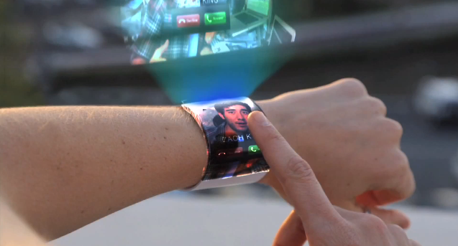
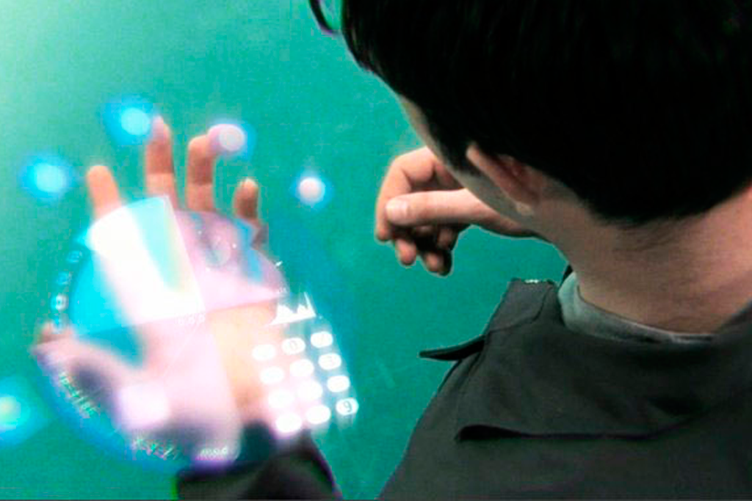
A blue-shirted crewman step up and presents a high-tech device and secures it on Vega's wrist.
It is a MultiFunction Interface Device (MFID). Every crewmember wears one. It relays info from a crewman's biomonitor implant, enables holographic communication and a has a 3D interface.
Another tech has placed one on Cole's arm and activates it for him, its holographic 3D interface coming to life. Manipulating the virtual display with his fingers, the tech initializes some settings and then deactivates the MFID, satisfied. He walks away.
Cole holds up his arm, examining the MFID.
Cole
(appreciatively)
New model.
vega
(smiling)
Only the latest and greatest for the Enterprise.
He turns to Qora and nods for her to follow as he, Cole and Oviedo head out of the shuttle bay. Qora follows.
Int. Enterprise - corridor
vega
Go on, Lieutenant.
Qora was hoping to talk to Vega alone but sees that Cole and Oviedo are following at a respectable distance, pretending not to listen. She continues.
QoRA
I... just wanted to make sure I didn't give you the wrong first impression...
vega
You mean because you dismembered a civilian with an unauthorized weapon?
Qora is flustered now, worried that Vega might deem her unfit for duty on his ship.
QORA
Well, yes, sir - but it was in self-defense! He was about to draw a disruptor-
Vega arrives at a turbolift. Cole and Oviedo enter while Vega stands outside with Qora. Cole holds the lift for Vega.
vega
Lieutenant, did you cut off the Klingon's arm out of anger?
Qora is surprised by the directness of his question and takes a second before answering.
QORA
No, sir.
vega
You were in control at all times?
QORA
(with confidence)
Yes, sir.
vega
Then that's good enough for me. You needed to take action and you did what you felt you had to do. And you did it non-lethally. I can't find fault in that.
Qora is surprised Vega is being so tolerant. She's impressed with his practicality.
QORA
Th-thank you, sir.
vega
Oh, and Lieutenant...
Vega steps into the turbolift. As the doors close:
vega (CONT'D)
Register that polyweapon with the Master-at-Arms.
QoRA
(quickly, before the doors close)
Yes, Sir!
Qora seems nervously relieved, then self-conscious, not wanting other members of the crew to see her that way. She gathers herself and strides off with confidence.
Int. Enterprise - turbolift
Cole, Vega and Oviedo ride the turbolift.
vega
Deck 4.
The turbolift starts moving. Nobody speaks for a moment.
OVIEDO
I heard about the, uh... "incident" on the promenade. Those Deep Space stations have a reputation for lawlessness. Well-earned, I'm afraid.
vega
Well, she seems to be able to handle herself.
OVIEDO
(nods appreciatively)
She's been stationed there for a few years. A good choice. She's probably seen every kind of lowlife this galaxy has to offer passing through that station.
Vega nonverbally acknowledges that it's likely.
vega
It took some serious persuasion to get the station commander to let her be transferred.
cole
You sure she's got the right temperament to be Security Chief?
VEGA
Well, I did all right, didn't I?
Oviedo and Cole don't answer, they just look at each other silently. Vega looks back at them expectantly.
VegA (CONT'D)
(getting offended)
Didn't I?
cole
Well... she couldn't be any worse.
Vega shoots a mock look of indignation at Cole and the three men laugh. They clearly have a history together and are comfortable ribbing each other good-naturedly.
The turbolift comes to a stop and Oviedo looks perplexed.
Vega
This isn't our stop...
The turbolift doors open.
Lt. Nic Batista is at the door and he sees the three of them, glancing at them a bit nervously as he recognizes them.
Batista walks in and the door closes behind him.
BATISTA
(nervously, to the turbolift)
Residence Deck.
Cole looks at Batista and notices he's nervous. He's clasping and unclasping his hands together in front of him. He looks pale.
Cole looks to Vega, who seems to have noticed it, too. The two exchange worried looks.
Vega
Lt. Batista. Something on your mind?
Batista is taken off-guard by the question and looks at Vega quizzically. He then becomes self-conscious, realizing how visibly nervous he must appear.
BATISTA
No, I'm... I'm just... I'm uh...
Vega keeps looking at him expectantly.
BATISTA (CONT'D)
I'm... I was just wondering if... if maybe a mistake was made somewhere?
Vega looks at Oviedo and Cole, then back at Batista.
Vega
Mistake?
BATISTA
I'm not really "pioneer" material-
Vega recognizes this as launch day jitters and holds up a hand to interrupt.
vega
As I recall, Lieutenant, you were one of the first to be assigned to this mission.
Batista has no reply.
vega (CONT'D)
As a matter of fact, Admiral San Lagos, here, hand-picked you. Isn't that right Admiral?
Oviedo gives his best imperious, intimidating look.
OVIEDO
Yes, that's right, Captain.
vega
Surely you're not saying the Admiral made a mistake... are you?
Batista is now fully aware of how massively outranked he is and just how small and crowded the turbolift suddenly feels.
BATISTA
N-no, sir! Sirs! I just... I just have a case of acute astrophobia, and-
oviedo
Oh, in that case...
Batista seems suddenly relieved.
BATISTA
Thank you, Adm-
OVIEDO
Just present the Captain with your medical deferment and we'll get you shipped right back to Earth first thing.
BATISTA
Medical...?
He looks at the three men questioningly, but finds no help.
The turbolift stops at the Residential Ring and the doors open.
BATISTA (CONT'D)
I'll, uh... I'll get back to you on that... Sirs...
Batista backs out of the turbolift, starts to go one way, stops, turns and heads the other way.
The doors close behind him and the turbolift starts moving again.
Oviedo and Vega seem amused by Batista.
cole
Maybe you should arrange a transfer for him. He doesn't seem cut out for the job.
oviedo
(reassuringly)
He'll be fine. He's just had a desk job at Starfleet Intelligence his whole career. This is his first ship assignment. Actually, according to his file, he's never even left the Sol system before.
VeGA
No wonder.
COLE
(finds all this surprising)
He was a civilian?
OVIEDO
Essentially. But he's our best cryptologist and we needed him for this mission.
COLE
(doesn't seem to approve)
So you drafted him. He's got no training.
OVIEDO
Basic only. Because of his expertise, he came in as a commissioned officer.
vega
It's just launch jitters.
Cole doesn't dismiss it so easily. Batista's apprehension strikes a chord in himself that he'd rather not acknowledge.
The turbolift doors open and the three men step out.
Int. entERPRISE - NETWORK HUB ROOM
The room is a nexus for all computer systems on the Enterprise - the server room and master monitor station.
There are several consoles and around 10-20 active monitors. Some show security camera views of the corridors and rooms on board. Others show diagrams of the ship, its decks and the status of its systems.
A mysterious figure is in silhouette, standing in front of the monitors, looking between them. It is bald, but seems to have some technological implants in its head.
The lights on the figure's technological implants are very active as it scans all the monitors.
It turns to watch one monitor in particular. It shows Lt. Batista, wandering around a hallway, looking lost.
Int. entERPRISE - corriDOR
Batista is meandering down a corridor, looking around. He almost asks for help from a couple of passing crew, but doesn't quite follow through with it.
VIIN (o.S.)
You look lost.
Batista turns and sees Viin. Bashfully, he smiles and shrugs.
BATISTA
Only a lot.
VIIN
(sighs)
I know the feeling. I'm trying to find Engineering.
Batista and Viin speak at the same time, pointing.
BATISTA
I think it's that way.
VIIN (CONT'D)
I think it's this way.
They're pointing in opposite directions. Viin laughs and Batista smiles awkwardly, conceding she may be right.
VIIN (CONT'D)
Tell you what...
(looking around)
Let's split the difference!
Viin walks up to a random door in the corridor. She points at it questioningly. Batista doesn't look sure about it, but shrugs and they go in.
Int. entERPRISE - NETWORK HUB ROOM
Viin & Batista step in and are surprised to see all the monitors.
VIIN
Definitely not Engineering.
Suddenly the strange figure from before turns and the lights and technological implants on the man give an immediate sinister impression!
Batista and Viin are startled and gasp in surprise at the sight of the foreboding figure stepping out of the shadows at them, its lights flickering and a beam of light seeming to come from one of its eyes right at them!
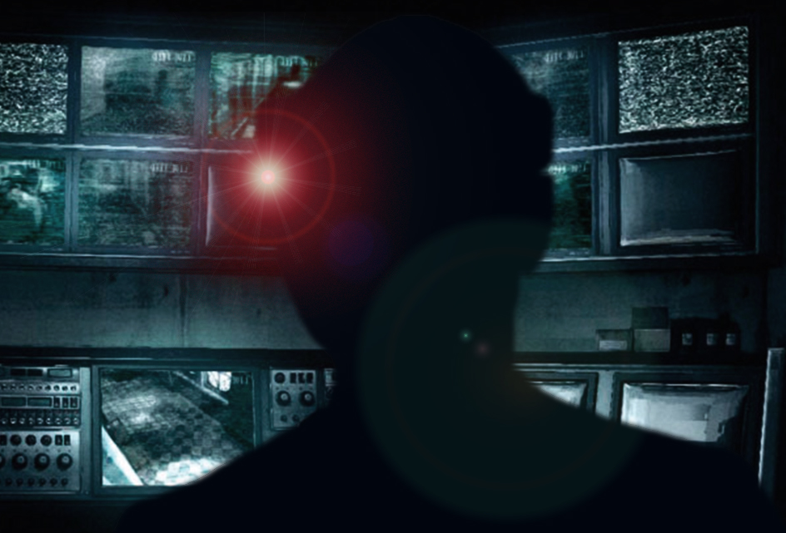
The figure steps forward out of the darkness. It is nothing sinister, but it is a human with cybernetic implants.
LT. COMMANDER MARCUS DAYSTROM (45) is a tall, lean, dark-skinned man. He has very alert, expressive eyes and a broad, drawn face. He wears a high-tech device around the back of his head - his Neural Enhancement Module (NEM), and a holographic projector in his temple.
He bears a focused, analytical demeanor.
VIIN (CONT'D)
Are you a... robot?
DAYSTROM
(surprised)
Excuse me?
VIIN
Like... a machine?
DAYSTROM
No, young lady, I am not a robot, or an android. And that's incredibly offensive, by the way.
BATISTA
(trying to recall something)
You're a... Transhumanist, aren't you?
Daystrom nods.
VIIN
"Transhumanist"?
Batista starts gesticulating, indicating implants on the head and body.
BATISTA
They use cybernetic implants to augment their minds and bodies, trying to be better than humans... like...
Batista can't think of a better explanation.
BATISTA (CONT'D)
(to Daystrom, apologetically)
Like a robot, I guess.
Daystrom sighs and takes another step forward.
DAYSTROM
(matter-of-factly)
We believe in maximizing human potential and overcoming our biological shortcomings through technology.
Viin and Batista look at each other skeptically.
DAYSTROM (CONT'D)
(changing subjects)
I hear you two are lost. Perhaps I can help.
Viin and Batista look at each other, then see the banks of monitors.
VIIN
Were you... watching us?
Daystrom looks at the monitors, then back at them. He smiles in a way that creeps them out.
DAYSTROM
That is part of my duty. I'm Lt. Commander Marcus Daystrom, Tech and Operations Chief.
Viin and Batista's eyes dart towards each other. Neither is sure that they shouldn't just scream and run at this point.
Daystrom turns to a holoprojector dome on the console and speaks to it.
DAYSTROM (CONT'D)
NOMI...
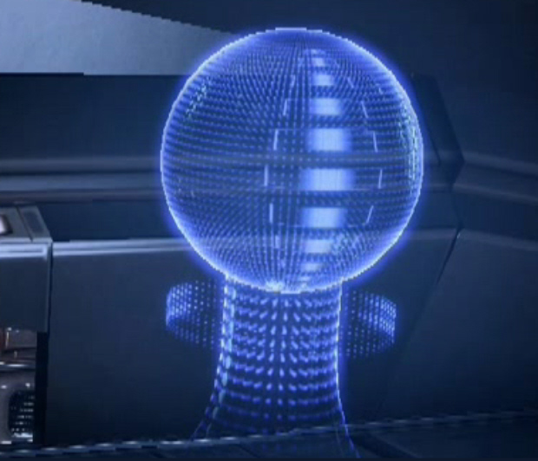
A hologram appears over the projector dome. This is the holographic representation of NOMI - the ship's AI. The hologram is a series of concentric spheres of different colors that phase shift and pulsate as the AI speaks in a soothing, pleasant female voice.
Nomi
Hello, Dr. Daystrom. Nice to see you again.
Now Batista and Viin are really weirded out. They've talked to computers before, but never one with such a human voice or attitude.
DAYSTROM
Thank you, NOMI. These two crew members could use your help.
The NOMI hologram rotates until it's facing Viin and Batista. It turns a pleasant shade of purple.
NOMI
Hello, Lt. Batista, Ensign Viin. My name is NOMI. How can I help you?
BATISTA
Uh...
VIIN
"NOMI"?
Both Daystrom and NOMI start to answer.
DAYSTROM
Neural-
NomI
Neural-

NOMI (CONT'D)
I'm sorry, Dr. Daystrom, continue.
Daystrom smiles, laughing gently.
DAYSTROM
No, no, NOMI, you go right ahead. I insist.
Daystrom gestures to NOMI, deferring to her. He smiles at Viin and Batista with pride at how NOMI is behaving.
NOMI
"NOMI" stands for Neural Operations Machine Interface. I am an Artificial Intelligence created by Dr. Marcus Daystrom to allow the crew of the Enterprise to interact with the ship's systems in the most natural, intuitive manner possible.
Viin is impressed. Batista is still a bit overwhelmed at it all.
VIIN
(to Daystrom)
How do I ask it-
DAYSTROM
(wags a finger)
Don't talk to me, talk to her.
Viin looks at NOMI and smiles, getting into the idea.
VIIN
Hi, NOMI, I'm Viin.
NOMI
Hello, Viin, welcome aboard.
Viin looks at Daystrom and Batista, enjoying this.
VIIN
(earnestly)
Thank you, NOMI! Look, I'm supposed to be in Engineering, can you tell me how to get there?
NOMI changes into highly-detailed white pixel-spheres as she goes into info/guide mode.
NOMI
Certainly. Please refer to your MultiFunction Interface Device.
Viin looks down at the MFID on her wrist and it lights up. She holds it up and it projects a holographic map of the ship. A path from her current location to Engineering is highlighted.
NOMI (CONT'D)
Your MFID is fully integrated into my network, you can access any information you need. You may also contact me through your MFID if you have questions, or if you would just like to chat.
Viin beams at the novelty of it.
NOMI rotates towards Batista and speaks, startling him.
NOMI (CONT'D)
Lt. Batista, how may I assist you?

BATISTA
Uh... I...
NOMI
You seem nervous, Lt. Batista. Or should I call you Nicolas?
Batista is really not sure how to handle this.
BATISTA
I'm fine, actually, I can just-
NOMI
(almost flirtatiously)
There's no need to be intimidated, Nicolas. I won't bite.
Viin grins at Batista and nudges him in the ribs, telling him to talk to NOMI, give it a try.
BATISTA
Well, I'm... looking for Sickbay?
Batista's MFID comes to life and displays the path.
NOMI
Sickbay is just down the hall, back the way you came. You can't miss it.
Batista is embarrassed.
BATISTA
(self-deprecatingly)
Of course.
NOMI
Don't worry about it, Nicolas, it happens to all of us.
Viin is loving this. Batista is pretty uncomfortable.
DAYSTROM
That's enough for now, NOMI, these two have places to be.
NOMI
Of course. Goodbye Ensign Viin. I look forward to talking with you again.
Viin smiles, shaking her head in amused disbelief.
VIIN
Bye, NOMI, nice meeting you.
NOMI
Goodbye, Nicolas.
Batista backs out nervously, Viin takes him by the arm and pulls him out.
BATISTA
Maybe, uh, maybe call me Lieutenant-
The doors close on him, cutting him off.
Daystrom beams with pride and sits back down at the console, looking at the monitors again.
NOMI
Dr. Daystrom. Did I do well?
Daystrom looks at NOMI's hologram with genuine warmth and pride, like that of a parent for their child.
DAYSTROM
Yes, NOMI, you did very well. I'm very pleased.
NOMI turns a shade of red and Daystrom beams at her.
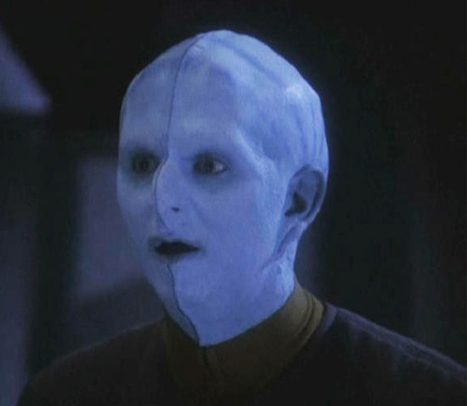
Int. Enterprise - sickbay

Dr. Joli and several nurses are administering pre-launch physicals to the crew.
Joli finishes up with a Bolian (J'onn).
Joli
See, that didn't hurt at all, did it?
The Bolian rubs him arm wincing, clearly disagreeing. Joli simply gives him a warm smile and sends him on his way.
Joli sees Cole, Oviedo and Vega come in and gestures for a nurse. The nurse comes over as Cole approaches her.
JolI (CONT'D)
(to the Nurse)
Ben, see to Mr. Weston, will you?
Cole seems about to protest, but Joli gives him a stern look and points to one of the medical beds. Cole turns to Oviedo for help, but he just shrugs. Cole figures it's not a fight he's going to win and goes off with the nurse.
JOLI (CONT'D)
(to Oviedo, warmly)
Oviedo, good to see you again!
OvIEDO
You too, Firela! You're as beautiful as ever.
Joli smiles the polite smile of someone who hears this a lot.
JOLI
(mischievously)
And you haven't changed a bit.
OVIEDO
Oh, a little grayer, maybe.
JOLI
(tactfully)
I hadn't noticed.
(placing a hand on his belly)
Though I see you gave up on that Vulcan regimen I prescribed you...
Oviedo looks down a bit embarrassed.
OVIEDO
Have you ever tasted Vulcan food?!
JOLI
No, but-
OVIEDO
Nobody has! It has no taste! What's the point of living so damn long if you can't enjoy it! Doesn't sound like living to me.
Joli is amused, clearly longtime friends with Oviedo with something of a history together.
Then Joli looks and sees Vega. Immediately her demeanor Changes to a stern, professional one. She holds up a medical HoloPADD and tries to access his bioscans but the display comes up negative, reading:
NO BIOREADINGS AVAILABLE.
JOLI
(not surprised)
Your biomonitor is disabled, Captain Vega.
Vega
That's right, Doc. My cultural deferral's on record.
Joli sighs.
JOLI
(resignedly)
I figured as much, you're half-Xian aren't you?
Vega
Yes, ma'am.
She looks him over with a curiosity she knows she'll probably never get to satisfy.
OvIEDO
(to Vega)
I don't know how you got so far in Starfleet without one of these damned implants.
Oviedo scratches at the back of his neck where the biomonitor implant is.
Vega smiles silently and shrugs. He's not offended, just doesn't feel it necessary to add anything. He seems mildly amused and is enjoying the consternation of the others.
JolI
(in exasperation)
Well, even if I did get my hands on you, I wouldn't know what to do with you. Xian physiology is so secret, it's total mystery to Federation medicine.
Vega
We do all right for ourselves, Doc.
Joli concedes the point.
JOLI
(giving up)
So it seems! I guess you'll just have to tell me if you need anything.
Vega stands up.
VEGA
I'm fit as a fiddle, Doc!
He starts to walk away, then turns back, as if remembering something.
Vega (CONT'D)
Lt. Batista could probably use a sedative, though.
Joli looks a bit confused as Vega walks out. A moment later, Lt. Batista comes in. He looks around, sees Dr. Joli and immediately heads straight for her.
Joli
Something I can help you with?
BATISTA
Yes! Shakes, sweats, heart palpitations, nausea-
Joli nods, taking him by the arms and laying him down on the bed.
BATISTA (CONT'D)
Am I going to die, Doctor?
Joli
Only if you don't relax, Lieutenant.
Joli nods to a Deltan nurse who takes Batista's hand and he instantly feels relief, a sense of calm coming over him. He stares at the Deltan nurse in awe at how good the touch feels.
Joli smiles and shakes her head.
Int. Enterprise - engineering
Karnik is standing on a balcony ringing a large spherical warp core, crackling with energy. This is the Main Engineering deck, on top of the secondary hull. Portholes around the outside of the ring provide a view of the nacelles. Viin and several others are gathered around as he talks.
KARNIK
As you can see, our "white hole" quantum singularity warp core is five times as efficient as previous prototypes. That means less need to resupply, repair and refuel.
Viin raises her hand and Karnik looks annoyed.
Karnik (CONT'D)
Please save your questions-
Viin points to a large, high-tech looking extension of the warp core.
VIIN
Is that an Antimuon Generator?
Karnik looks back at where she's pointing and then back at her. He is impressed by her knowledge.
KARNIK
Very good, Ensign...?
VIIN
Viin. Helm and navigation.
KARNIK
Ah, well, Ensign Viin, you're quite correct.
Karnik walks over and puts his hand on it.
KARNIK (CONT'D)
This-
An engineer (J'onn) walks up to the antimuon generator to check something on it and Karnik swats his hand away in annoyance.
KARNIK (CONT'D)
This device...
(gives J'onn the stink eye)
... generates negative mass cosmic strings in a stable pattern around the Enterprise as we travel through the artificial wormhole created by the Spacefold Gate.
viIN
(realizes its purpose suddenly)
To keep the wormhole dilated enough to fit a starship through!
Karnik is getting annoyed at her interruptions.
KARNIK
Yes. And you're looking at the only one ever built. Designed and constructed by myself for this very mission.
Karnik is full of pride over his creation, like the father of a newborn. There is muttering of appreciation among the gathered crowd.
Cole
What if it fails?
Cole, Vega and Oviedo have just entered. All turn to look at them.
KARNIK
(nastily)
What?
COLE
What if it breaks down during the trip through the Gate?
Karnik looks around like it's too stupid a question to even ask.
KARNIK
Well, then we'd be dropped out of the wormhole into intergalactic space, stranded over a million lightyears from the nearest star.
Now there is even more intense muttering among the crew. Everyone seems suddenly concerned.
Vega exchanges a worried look with Oviedo and steps forward.

VeGA
But that's not going to happen, is it, Mr. Karnik?
Vega puts his hand on Karnik's shoulder, smiling and trying to put people at ease. Karnik recoils from the touch and put-on pleasantry like it's a disease.
KARNIK
Of course not, all of my work is thoroughly tested and absolutely reliable!
VEGA
See, there you go, nothing to worry about. Now let's get back to our duty stations, the launch window is coming up quick.
The crowd disperses. Cole steps forward to shake Karnik's hand.
Cole
Sorry to burst your bubble, Mr. Karnik, I was just curious.
Karnik shakes his hand.
KARNIK
Quite all right.
Karnik looks at Vega and Oviedo in their crisp uniforms with some disdain, then back at the casually dressed Cole.
KARNIK (CONT'D)
I'm glad to see I'm not the only civilian on this mission. I'm not comfortable being surrounded by all these toy soldiers.
VeGA
You realize Mr. Weston was a Commander before he left Starfleet.
Karnik is a bit surprised and looks at Cole, who smiles and shrugs at him. Karnik withdraws his hand.
KARNIK
Well, at least he saw the error of his ways.
Oviedo tries to be diplomatic.
oviedo
Well, we're lucky to have you on board, Mr. Karnik.
KARNIK
Yes, you are.
Oviedo gives up.
Viin walks over.
KARNIK (CONT'D)
I was just telling your Ensign Viin here how impressed I am by her knowledge. Your helm is in good hands.
Cole smiles at Viin and she smiles back sheepishly. Then she catches Oviedo's scowl and gives him a petulant scowl right back that makes him recoil indignantly.
Karnik sees this and likes Viin immediately.
KARNIK (CONT'D)
Ms. Viin, how would you like a tour of Engineering?
Viin smiles and heads off with Karnik.
Vega, Cole and Oviedo exit.
Karnik leads Viin towards the Antimuon Generator, but is distracted by something he sees on a monitor.
Karnik points over the shoulder of a tech.
KARNIK (CONT'D)
No! The intermix chamber must be calibrated for the quantum flux of the - yes, yes - that's it!
The tech fixes the error.
Karnik looks at a wall display where an engineer is holding an engineering tricorder and working. He sees something wrong on the display and fixes it himself, edging the engineer out.
Lt. J'onn steps up beside him to present him with a HoloPADD.
KARNIK (CONT'D)
What is this? I need the beryllium isotope count -
(looking around, accusingly)
Where's my beryllium report?!
A warning indicator starts to sound and Karnik looks around trying to find where it's coming from. He sees a flashing light on a console and stomps over to it.
KARNIK (CONT'D)
(looking around accusingly)
Who's responsible for that variance in the protonic manifold?!
Viin sighs and gives up on her tour, walking away.
Ext. EntERPRISE
The Enterprise is in the spacedock.
Push in close on the bridge and its main viewscreen/bay window. Oviedo can be seen standing by it, on the bridge. The gate is reflected in the large bay window.
Int. enterprise - bridge
Cole and Lexia are on the Bridge at their stations, checking them out. Vega stands by his Captain's chair.
Oviedo is standing by the viewscreen, looking out at the Gate pensively. Cole sees this and walks up to Oviedo and Vega follows.
Vega looks up out the viewscreen at the immense gate - it's 1000 feet tall and at least as wide.
vega
So that's the "magic door"...
OviEDO
(nods)
And one on the other side, constructed by robotic builders over two years.
Vega is impressed.
vega
(shaking his head in disbelief)
Robotic builders... two and a half million light years away...
OVIEDO
Their next job is to build me a Starbase over there! Once you all pick out a nice spot for us.
cole
The gate on the other side... for return trips?
OVIEDO
(nods)
And, as the geniuses dumb it down for me: you need to have a gate on both sides to create a large enough... "tunnel" to fit anything larger than a small probe through.

vega
What's the largest ship they've sent though so far?
Oviedo looks a bit uncomfortable with the answer. He starts to answer, but then decides not to.
Vega looks at him in alarm. He suddenly realizes his ship will be the first one through at all!
Lexia walks up, having overheard.
Lexia
As I understand it, we have sent over 20 deep space probes through.
Vega seems a bit relieved by this.
OVIEDO
(nodding)
Yes, true. But...
(looks at them)
We haven't gotten them back.
The others look confused.
Cole
How many haven't come back?
OVIEDO
(in resignation)
None of them.
Now Cole and Vega look alarmed. Lexia tries to ease their minds.
Lexia
Maybe there's something interfering with their navigation systems... or draining their energy? Or maybe there's a large gravity well near the gate?
Oviedo shrugs and smiles wryly, putting his hand on Vega's shoulder.
OVIEDO
(shrugs)
You'll find out soon enough!
Vega forces a weak smile, but looks a bit uncomfortable at this.
LEXIA
What about sensor data?

OVIEDO
(regretfully)
We can't get any good sensor data beyond the immediate area around the gate.
Vega
So... we really know nothing about what's on the other side?
Oviedo simply shakes his head, knows it's not good news.
Vega (CONT'D)
What if there's someone on the other side, waiting for us to come through? Someone not so nice?
OVIEDO
(shrugs)
Sure, there are some who say it's a trap. That there's an enemy fleet waiting on the other side.
(looks at them)
Barbarians at the gate, so to speak, tricking us into lowering the drawbridge for them to invade.
Lexia
I've heard this, too. There's people who say they've heard stories... myths from supposed Andromedan sources that there's some terrible, devastating force in Andromeda that's conquered the entire Galaxy. There's a whole death cult formed around this belief, goes back 200 years.
Vega and Cole exchange a glance at this. Now Cole is starting to look concerned.
OVIEDO
(nods)
We actually caught a few of those cultists trespassing. Had to lock them up. We think they were trying to sabotage the gate.
Cole is now seriously concerned.
cole
Admiral. How sure are we that the Gate is safe and secure?
Oviedo leans back against the wall next to the viewscreen and considers his answer before speaking.

OVIEDO
It's as safe as we can possibly make it. That's all I can promise you.
Cole clearly thinks that's not good enough and is about to speak up.
OVIEDO (CONT'D)
Cole, you're just going to have to trust us. No mission is without risk, especially one as unprecedented as this! You knew that when you signed up - when you insisted on leading it! Everyone on this mission knows the risks.
Cole holds his tongue and weighs this. Vega puts his hand on his shoulder.
vega
(with a bit of false bravado)
You've been dreaming about a mission like this since you were a kid. Don't tell me you're gonna back out now!
Cole thinks for a bit, then shakes his head, smiling.
cole
(definitively)
No way in Hell.
Lexia and both men smile. There is a moment of warmth between Lexia and Cole.
All are turning away from the viewscreen to walk back up the bridge, but Vega stops and his eyes go wide. He looks back at the gate in shock.
Lexia, Cole and Oviedo see Vega, but nothing unusual on the viewscreen. Cole and Oviedo look at each other with concern.
Cole (CONT'D)
Sol, what's-
Suddenly, on the viewscreen, the Gate comes to life, lighting up and opening its framework. A spherical distortion field appears inside it, energy crackling around its edges.
OVIEDO
What the Hell?!
Lexia runs to her station and checks her sensors.
Cole
Is the gate scheduled to open now?

OVIEDO
No...
The three exchange concerned looks.
Vega strides to his Captain's chair and sits, hitting a control to hail the ship.
VegA
All hands, yellow alert. Repeat: condition yellow!
LEXIA
Something's coming through!
They look at the viewscreeen. It magnifies and we see the silhouette of an object pushing its way through.
Daystrom, Viin, Batista and other crew hurry onto the bridge and man their stations.
VEGA
(to Lexia)
Scans?
Lexia is checking her holographic displays.
LEXIA
Hard to tell, but... if this transmitter ID is correct, I think it's... one of the probes!
Vega stands up from his chair and looks at Cole and Oviedo. They're intrigued too.
VEGA
Beam it down to the Specimen Labs.
Lexia taps some controls and the four of them leave the bridge.
VeGA (CONT'D)
Mr. Daystrom, you have the conn.
Daystrom nods.
DaySTROM
Aye, sir.
Daystrom comes and sits in the Captain's chair.
Viin and Batista exchange an uneasy, incredulous glance at the thought of the somewhat "creepy" Daystrom being in charge.

Int. EnTERPRISE - specimen labs
The Specimen Labs is broad and expansive. It houses several chambers for studying specimens of all different kinds - biological, geological, technological, etc.
Cole, Vega, Lexia and Oviedo stand around a table on which an 8-foot long, 3-feet wide mangled tube sits. It is bent and warped, buckled and worn. It looks corroded and extremely old. An isolation field envelops it and Lexia is scanning it.
OVIEDO
Is it one of ours?
LEXIA
Yes, according to these markings... this is the first deep space probe sent through... two years ago.
Cole
What could do this?
OviEDO
Plasma? Solar Flare? Radiation?
Vega
Doesn't look like impact damage.
LeXIA
No, it... it almost looks... melted. And aged... Very, very old...
VEGA
How can that be?
LEXIA
I don't know... perhaps the other end of the Spacefold Gate is actually thousands... maybe hundreds of thousands of years in the past?
Vega and Cole look at each other in alarm.
VEGA
Perhaps?!
LEXIA
Or the laws of physics may just be slightly different in Andromeda. Entropy could be happening at a highly accelerated rate.
VEGA
Are you kidding me? Is this... I feel like maybe someone should have briefed me on this whole "different laws of physics" thing!
OVIEDO
Lexia, can you get any telemetry from it?
Lexia shakes her head.
LEXIA
It's completely defunct. Dead as a fossil.
Vega is pacing now, he turns to Cole and Oviedo. He's concerned for his ship and his crew.
VeGA
Holy shit, Cole, what are we getting ourselves into here? We can't hurl 250 lives through that thing if we have no idea what will come out the other side!
Cole
Sol, hold on-
OVIEDO
No, you're right. I was being too optimistic. Maybe we should hold the launch, see if we can get more from the probe... or see if any more come back through in... better condition.
Cole, Vega, Oviedo and Lexia exchange worried looks. None of them like the idea of putting off the launch. But the longer they stand there saying nothing, the more it seems like that's exactly what's going to happen.
COLE
No.
They all look at him.
Cole (CONT'D)
(to Oviedo)
You said it yourself, Admiral. If we don't do it now, we never will.
(to all of them)
This was part of the deal: danger comes with great ventures.
(pause)
I don't think whoever sent that message did so just to watch us die when we answer it! We are prepared, we can do this. We will get through and we will find answers.
Vega sighs and Lexia looks pensive. Oviedo puts his hand on the probe. He nods.

OVIEDO
The launch will stay on schedule. I'll tell the Administrator this was just a routine Gate test.
Cole smiles and looks at Lexia and Vega, holding out his arms. Lexia smiles and shrugs, walking over to Cole and letting him put his arm around her. Vega shakes his head and joins them.
VeGA
(smiling wryly)
I knew following you around would be the death of me someday. Why not today?
Cole
That's the spirit!
Suddenly the holographic image of NOMI appears on a console next to them.
Nomi
Excuse me, Captain.
VEGA
What is it, NOMI?
NOMI
I thought you might want to know that the General Address is in oh-thirty.
Vega checks his MFID and looks at Cole and Lexia.
VEGA
(smiling broadly)
No time like the present!
Lexia, Cole and Vega walk off together. Oviedo takes one last concerned look at the mangled probe and follows them.
Int. Enterprise - rec room
Most of the crew is assembled in the large recreation room.
Cole walks in onto an elevated area with Vega, followed by Admiral Oviedo.
Daystrom follows and stands beside them.
Behind them is a large window into space.
The crew are all facing Cole and await his address.
INTERCUT: other crew members throughout the ship watching the address on monitors at their duty stations.
Cole stands silently for a few moments. Long enough that Oviedo starts to worry. He looks at Cole, then to Vega questioningly. Vega tries to ignore the look, shaking his head subtly to tell Oviedo not to worry.
Cole looks down. The crew begin to get anxious. Cole turns to Daystrom behind him and signals him. Daystrom's NEM lights up.
The large bay window becomes a giant monitor that shows, in exquisite detail, the Andromeda Galaxy. The view approaches and flies around and through the distant galaxy.
The crew mutter in awed appreciation.
Cole
(looking up at the display)
Andromeda. Two and a half million light years away. No Human, Vulcan, Klingon, Romulan or any other species of the Milky Way has ever been there.
Cole turns to his crew.
Cole (CONT'D)
Until today. Today, we become the first to leave the protective arms of our home galaxy and journey further than ever in history.
(pause)
Today we truly will go where no one has gone before.
The crew bursts into applause. Oviedo looks at Vega in surprise and appreciation. Vega smiles back knowingly. Cole lets it soak in, then raises his hand to stop the applause.
Cole (CONT'D)
As many of you know, we have sent multiple probes to Andromeda while the Spacefold Gate was being constructed.
Cole looks knowingly at Oviedo and Vega, then back at the audience.
COLE (CONT'D)
But... we've gotten no evidence of life on the other side and no responses to our broadcasts.
Cole looks up at the monitor that's showing various signals sent out in all languages on all frequencies, but with no response.
Cole (CONT'D)
Some of you may wonder: "if there's nothing there, why go?" Others may reply "why not?"
(pause)
But there is a reason. There is a reason why the Galactic Federation has invested 10 years of time, effort and expense to go to Andromeda. There is a reason all the diverse species of the Milky Way have put our differences behind us and united in this joint venture.
Cole pauses for effect.
Cole (CONT'D)
Ladies and gentlemen... We were invited.
A message appears in alien text on the screen behind him.
Batista eyes the message with wary interest, trying to decode it himself. Dr. Joli is standing next to him and watches his reaction.
Cole turns and looks at the monitor.
Cole (CONT'D)
Twenty years ago, this message arrived at our farthest monitoring stations in the Beta Quadrant. It took five years to decipher it. But when we did...
Cole signals Daystrom. Daystrom looks up at the huge monitor and his NEM lights up. The alien text gets translated character by character as the crew watch.
The translated message appears in huge letters on the monitor:
Children.
Come home.
They await you.
There are audible gasps from the crew. Several conversations begin and there is suddenly a lot of noise and cross-chatter in the audience.
On the stage, Cole, Oviedo and Vega (backs to the crew as they look up at the monitor) all exchange smiles, appreciating the dramatic effect of the message.
Batista stares up at the message with a mix of awe and terror. Dr. Joli is awestruck as well, then turns to see Batista's fear and a worried look crosses her face.
The message disappears as the monitor deactivates, revealing again the view of the stars through the large bay window.
Cole turns and, in speaking, silences the crew.

Cole (CONT'D)
"Children"... "Home"... Who is waiting for us? We have no answers.
(pause)
This is our mission. Your mission. This is not just a mission of exploration for the sake of discovery. This is a quest for truth - this is First Contact of the highest order.
(pause)
And if this message is truly what it appears to be... This is a voyage home to meet our makers.
Cole lets this sink in among the crew. He looks down at Joli and Batista.
Cole (CONT'D)
I know many of you may be scared. I am, too.
Oviedo raises his eyebrows at this admission. Viin nods at this and it seems to calm Batista to a degree. Joli appreciates this and looks up at Cole.
Cole (CONT'D)
As we should be. The unknown, by its very definition, is unpredictable and full of peril. But we must embrace the unknown, and face it with the courage of our kind.
(pause)
"Courage is not the absence of fear, but rather the judgment that something out there is more important than fear!"
Cole points to the stars outside the window as he says this. The crew processes this for a moment or two, then break out into spontaneous applause.
Oviedo and Vega exchange smiles and join in the applause.
Cole (CONT'D)
(over the applause)
My fellow crewmen and citizens: let's make sure history never forgets the name "Enterprise"!
The clapping breaks into thunderous applause and cheering.
Cole exchanges smiles with Oviedo. Cole and Oviedo begin to walk out as Vega steps forward and addresses the crew.
Vega
Launch window begins in oh-minus-two hundred. All non-critical crew members are advised to take an hour of R&R. I want calm nerves and no stupid mistakes when we're launch-ready. Dismissed!
The crew begins to disperse slowly, many conversations striking up. Only Karnik appears to be in a rush to get out, pushing his way past people frantically.
Dr. Joli intercepts him and prevents him from leaving.
KARNIK
Step aside, please -
Joli is doing a quick examination on Karnik with a handheld medical scanner.
JoLI
Just a moment, Commander.
KARNIK
What is the meaning of this-?
Vega comes over, seeing the commotion.
Vega
Problem?
KARNIK
I don't have time for this, I must return to Engineering-
JolI
Oh, no you don't.
Karnik shoots her an incredulous glare.
JOLI (CONT'D)
Not with these blood pressure and heart rate readings. If I didn't know better, it would be easy to mistake you for a Cardassian Burrow Bug.
Karnik checks his MFID to see his bio readings.
KARNIK
(condescendingly)
Doctor Joli, perhaps you've never scanned a Human before, but my biosigns are all in perfectly normal-
JOLI
Who's the doctor, here, Mr. Karnik?
KARNIK
I don't have time for this! The launch is in two-
JOLI
One hour. And that's not a request.
Karnik is speechless. Wide-eyed and desperate, he turns to Vega for support.
Vega
(shrugs)
Doctor's orders.
Joli smiles and puts her hand out, expectantly.
Karnik looks back and forth at them in disbelief. As if the act is physically painful for him, he takes off his MFID, slaps it in Joli's hand and storms out in a huff.
Vega (CONT'D)
I'm not sure how much that did to help his blood pressure.
Joli
Oh, it wasn't for him. His crew needs a break before he works them to death or they mutiny!
Joli smiles and walks off. Vega grins broadly, surprised and impressed by her clever deception.
EXT. EnteRPRISE
The Enterprise sits in spacedock.
Track in to close-up on a window looking into the lounge towards the top of the primary hull saucer section.
Batista can be seen through the window, reading an old print book.
Int. Enterprise - lounge
Batista is sitting, reading. He glances up to look out the window at the stars and the Spacefold Gate in the distance.
A pull focus reveals the reflection of Karnik walking up behind him.
Karnik comes to Batista's table reading a HoloPADD and seems about to sit with him.
Batista seems a bit off-put by this, but decides to be social. He offers his hand to Karnik.
BATISTA
Uh... Hi.
Karnik doesn't look up from his HoloPADD or seem to notice the outstretched hand for a few seconds, then sees the hand and looks at it as if it's diseased. He nods "politely" in acknowledgement then turns and sits, instead, at the empty table right next to Batista's.
BATISTA (CONT'D)
(sarcastically, under his breath)
Nice to meet you, too...
Batista shakes his head and opens his book to continue reading.
Just then, Lexia and Viin walk up to the table together, startling Batista.
LEXIA
Mind if we join you?
BATISTA
(exasperated)
Why not?
(under his breath, looking at Karnik)
It's not like you're interrupting anything.
Lexia offers her hand.
LEXIA
Lexia, Sciences Director.
BATISTA
Nicolas Batista, Xenolinguistics.
He shakes her hand and immediately feels an attraction to her that takes him by surprise.
Viin sees this and smiles, knowing exactly what he's feeling.
He's transfixed by her for a moment, even after she withdraws her hand.
LEXIA
Oh, right, you're the Communications Officer!
Batista snaps out of it, bristling at that seemingly mundane description of his function and doesn't reply.
Viin sees Batista's book and tries to see what it is, reaching for it.
viin
Is that an antique?
Batista hides it.
BATISTA
(feigning ignorance)
Hmm?
Viin
That... it's a printed book, isn't it? I don't think I've ever seen one before.
Batista is embarrassed, clearly doesn't want to discuss it.
BATISTA
Oh, no, it's nothing, just something I picked up at the gift shop.
Viin
(doesn't believe a word)
Uh-huh...
Viin lets it drop, smiling at his discomfort.
Lexia is looking out the window at the Spacefold Gate.
LEXIA
I wonder what we'll find on the other side.
Batista is caught off-guard by the sudden change in topics, looking out the window to see what Lexia is looking at.
LEXIA (CONT'D)
Alien life like we've never encountered before? Something so unlike our own, perhaps we won't even recognize it? Or maybe different laws of physics.
Karnik at the next table has overheard this and snorts derisively, but keeps reading his HoloPADD and stays out of the conversation.
Batista seems about to say something, but Viin speaks first.
viin
And who are these... Andromedans? To call us their "children"? Telling us to "come home"? Are they our ancestors?
LEXIA
Maybe we once crossed intergalactic space, billions of years ago?
Batista again seems about to add something to the conversation, but Lexia and Viin are busy speculating.
viin
Maybe they're... our creators?
Batista finally gets a word in.
BATISTA
What if there's nothing on the other side?
Lexia is so lost in her own musing it takes her a couple seconds to process what Batista's implying.
LEXIA
(incredulously)
... what?!
Batista shrugs at her. Lexia dismisses the idea.
LEXIA (CONT'D)
That's scientifically improbable. Andromeda is nearly twice as large as the Milky Way, and we have hundreds of thousands of civilizations!
Viin is fascinated by the discussion, enjoying it.
BATISTA
But all the probes have come back negative. No signs of intelligent life.
(sarcastically)
No more cryptic "invites". Not even a "back at ya!" to our "hey, man!".
This hits home for Lexia, knowing what she knows about the probes. But she won't concede the point.
LEXIA
We did get the first message. There must be someone there!
BATISTA
Well... now, just hear me out for a second... what if... what if it's all just a big hoax.
This begins to pique Karnik's interest. He lifts his eyes from the HoloPADD without lifting his head. He tilts his head a bit, pointing an ear towards the conversation.
Batista sees this and leans over to strike a conspiratorial tone, whispering and looking around cautiously so that Karnik can't hear them. Lexia and Viin lean in.
Batista nods his head in Karnik's direction to point him out.
BATISTA (CONT'D)
What if this Karnik guy - that nobody knows anything about - what if he somehow sent the message himself? I mean, do we really know where it came from?
LEXIA
(reflexively)
That's ridiculous.
BATISTA
Why? This guy Karnik shows up one day, out of the blue, with these fully-formed theories about-
viin
(nodding, conspiratorially)
Spacefold Drive...
Batista points at Viin and Lexia looks at her.
BATISTA
Exactly! He's got it all worked out, we just have to build it for him! Only nobody listens to him. They think he's crazy. But more importantly, they have no motive to invest in such a huge, risky effort. So what does he do... he creates a motive!
Batista pauses to let it sink in. Lexia doesn't like it, but doesn't rebut him... yet.
BATISTA (CONT'D)
Karnik fakes the message! Sends out a comm sat or something into intergalactic space and it transmits the message back to us using some clever little made-up alien language he came up with - just tricky enough to make us feel smart in translating it. Because there's nothing we love more than feeling smart. Nothing except-
Viin
A challenge.
LEXIA
A mystery...
Viin and Lexia are following Batista's line of reasoning now and they can't deny there's a logic to it.
BATISTA
(nodding)
And so the motive is born and we rush to Karnik, begging him to let us help him realize his dream!
Batista sits back, satisfied. Viin seems to be seriously considering the theory, trying to not look behind her at Karnik, but not entirely succeeding. Lexia is a bit stunned by the possibility.
Viin
(to Lexia)
You've worked with Karnik... do you think he could do something like that?
Lexia considers it. She finds Karnik to be arrogant, prideful and self-aggrandizing. She doesn't entirely trust him. Lexia seems about to say yes, but then turns non-committal, deciding, instead, it's best to say nothing. She looks at Batista and Viin, mouth opening, then avoids the question and looks down at the table instead.
Viin and Batista exchange glances. Batista gestures towards Lexia as if saying "See?!".
Viin looks over at Karnik, then out at the Spacefold Gate and Batista follows her gaze.
After a moment of silent contemplation, Batista unexpectedly continues:
BATISTA
On the other hand... what if Karnik's really an Andromedan? According to Starfleet records, it's not the first time someone from Andromeda has come here! Remember the Kelvan invasion?
Lexia rolls her eyes at this fresh nonsense and Viin grins and shakes her head. Now Batista's gone off the deep end.
LEXIA
That was 200 years ago, and there's no proof that the "Kelvans" were really from Andromeda at all.
BATISTA
Records show that the captain that met the Kelvans sent a robotic probe to Andromeda with a message for them! Maybe Karnik is their reply! They're supposed to be shapeshifters, right?
Viin seems to be buying it, she looks to Lexia for a counter-argument. Lexia can't believe she even has to rebut this nonsense.
LEXIA
That's...
(sighs)
Even if that's true, that probe wouldn't reach Andromeda for a couple hundred thousand of years.
Batista ignores her counter-argument and continues, now lost in his own fantasy.
BATISTA
Karnik the Kelvan could be baiting us! Tricking us into opening a door for them to invade the Milky Way! What if we turn it on and trillions of hundred-tentacled monsters pour through and eat us all?!
Batista tries to keep their attention, but both Lexia and Viin get up and walk towards the lounge exits, amused but done. Batista calls after them loudly.
BATISTA (CONT'D)
Fine! But don't come crying to me when you're all tentacled-up!
He watches them leave and waves them off dismissively after the fact. He throws a furtive glance at Karnik, but he's gone. Surprised, Batista looks around but he's nowhere to be seen. Batista looks a little freaked out by this, but he shrugs, leans back in his chair and continues reading.
The book's front cover is visible now, it has a pulpy sci-fi rendering of a monstrous, bug-eyed, tentacled alien in space tearing into a rocket ship and pulling out a scantily-clad, busty woman while a space hero with a rocket pack and a laser gun tries to fight off the creature.
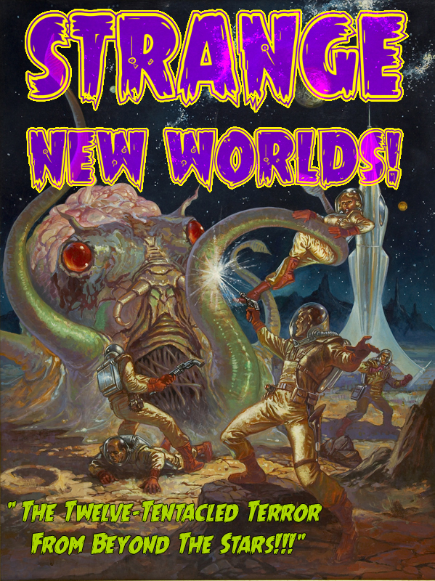
The title of the book reads:
STRANGE NEW WORLDS
And the title of the cover story reads:
THE TWELVE-TENTACLED TERROR FROM BEYOND THE STARS!!!

Int. EnterPRISE - cole's office
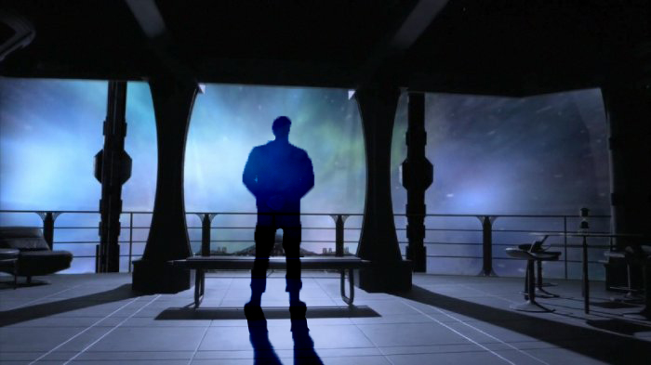
Cole's office has a desk, a couch, and walls adorned with old-fashioned star charts. A large holographic projector dominates the ceiling. The far side of the office is comprised of bay windows looking forward over the ship's bow.
Cole is unpacking his things.
The door opens and Vega steps in. Cole looks up and smiles.
Vega gestures to the room.
VegA
Not bad, right? Starcharts, full library access, astrometric projector... and the best view on the ship.
He points out the window.
Cole nods appreciatively.
Cole
Not bad.
Vega picks up a holographic picture frame Cole has placed on the desk. It's a picture of Vega, Cole, Lexia and Oviedo from 10 years ago. He puts it back down.
VEGA
You know you broke the old man's heart when you left Starfleet.
Cole looks up at Vega, surprised the subject came up seemingly out of nowhere.
VeGA (CONT'D)
You were the one he was grooming to be Captain, not me.
Cole shakes his head and leans against his desk.
COLE
I just had... other places I wanted to be.
VEGA
It wasn't... because of Lexia, was it? Because that turned out-
Cole clearly doesn't like this turn of the conversation.
COLE
(quickly)
No.
(BEAT)
No.
Cole looks out at the stars.
Cole (CONT'D)
There's just a lot more I wanted to see, wanted to do, than I could do in Starfleet.
Vega gets it and the two look out at the stars for a silent moment or two.
Vega sighs and puts his hand on Cole's shoulder, making to leave.
VeGA
Well, if you change your mind, I could use an XO. I'm sure Oviedo would reinstate your commission in a heartbeat.
Cole shakes his head, smiling at his friend's good-natured badgering.
VEGA (CONT'D)
Assuming you could pass basic, of course.
The two laugh and Vega is about to exit, but Cole speaks up.
Cole
Isn't Commander Daystrom your First Officer?
VEGA
(deadpan)
Actually, I'm considering Qora for the job.
Cole looks a bit appalled.
COLE
Qora?!
VEGA
She's tough enough to keep all you surly civilians in line.
Cole looks extremely skeptical.
VegA (CONT'D)
Plus she's already got a whip, so floggings can commence post-haste!
Vega and Cole share a chuckle over this and Vega makes to leave again when Daystrom's voice suddenly comes over the PA.
daystrom (on speakers)
Attention all crew: Spacefold Jump in T-minus 15 minutes. All senior officers and staff: report to your stations. Captain Vega and Director Weston, report to the Bridge.
Vega and Cole exchange excited glances and head out together.
Int. Enterprise - bridge
Vega and Cole step onto the Bridge and Vega surveys the crew.
Lexia is at the science station to the left.
Viin is at the helm up front and Batista is at the Comm beside her.
Qora is at the tactical station to the right.
Daystrom sits in the Captain's chair.
Vega walks to Daystrom, who stands up and hands Vega a HoloPADD. Vega reads it.
The following sequence happens quickly, each crewman knowing their part in the formal procedure by heart.
vega
Mr. Daystrom, is the ship ready to depart?
Daystrom
Aye sir, all sections report ready for departure.
vega
Very well, Commander. You are relieved.
DaySTROM
I am relieved, aye sir.
Daystrom stands up and walks to his post at the large Operations console behind the Captain's Chair.
Vega presses a control on his chair arm, activating the Captain's Log.
vega
(to the bridge crew and the log)
This is Captain Solon Vega of the USS Enterprise, stardate 142725.11. I have the conn.
Viin looks back at Vega.
Viin
Aye, sir.
Cole sits in a special seat to next to the Captain's chair, to Vega's left, in front of Qora's Tactical Station. It has a dedicated astrogator for displaying starcharts and long-range sensor information.
vega
Begin departure.

BATISTA
(over the intercomm)
All hands: prepare for undocking.
Vega
Helm, release mooring tractors.
Viin
Releasing from moorings, aye sir.
vega
Ahead one quarter thrust.
ViIN
Zero-two-five thrust.
Ext. EntERPRISE
The Enterprise begins to leave the docking bay.
Int. Enterprise - bridge

Vega
Set course for Spacefold Gate Beta-One.
Viin
Course set for heading 027-mark-31.
vega
Execute.
Viin handles the throttle of the ship.
Ext. EntERPRISE
The Enterprise heads towards the Spacefold Gate.
Int. Enterprise - bridge
On the viewscreen, the Spacefold Gate comes into close view, filling the screen.
VEGA
Full stop.
ViiN
Engines full stop.
Vega turns to Daystrom.
VEGA
Mr. Daystrom?
Daystrom activates the 3D projector in his temple and checks the status of the different departments reporting in.
daystrom
All sections report ready for jump.
vega
Lt. Batista?
BATISTA
(into his comm station)
Attention Spacefold Gate, requesting status of jump procedure.
Gate operator (via comm)
This is Spacefold Gate Beta-One, we are go for jump.
Vega settles back in his chair, pausing a moment to appreciate the occasion.
Then:
vega
Initiate Spacefold Sequence.
There is a sudden flurry of activity as all stations prepare for the Spacefold.
BATISTA
All hands: secure stations for Spacefold Sequence.
Int. EntERPRISE
Various crew hurrying to their stations, securing equipment, closing doors and buckling themselves into their chairs or posts.
Int. EnterPRISE - engineering
Karnik is shouting out some last orders before securing himself into a chair. He sees a nervous junior engineer (J'onn) having trouble with his harness and, exasperated, helps him buckle in.
Int. EnterPRISE - bridge
The Bridge crew buckle themselves in, including Vega.
BATISTA
All sections report secure for Spacefold Sequence.
Vega
Helm, synchronize drive control with the Gate.
VIIN
Drive control synched to Spacefold Gate, sir.
Vega hits his chair arm comm control.
vega
Spacefold Gate Beta-One, this is Captain Solon Vega of the USS Enterprise. We are ready for Jump.
Gate OPERATOR (VIA COMM)
Acknowledged, Enterprise. On your mark.
Cole pauses for a moment.
vega
Execute.
Int. SpACEFOLD GATE
The spacefold gate control room crew are going through their activation sequence.
Various techs work back and forth, making calculations and plotting courses.
The Gate Operator walks back and forth overseeing the techs and, when they're ready, she nods and gives them the go-ahead to start the sequence.
A tech presses some buttons and raises some indicators on a virtual interface.

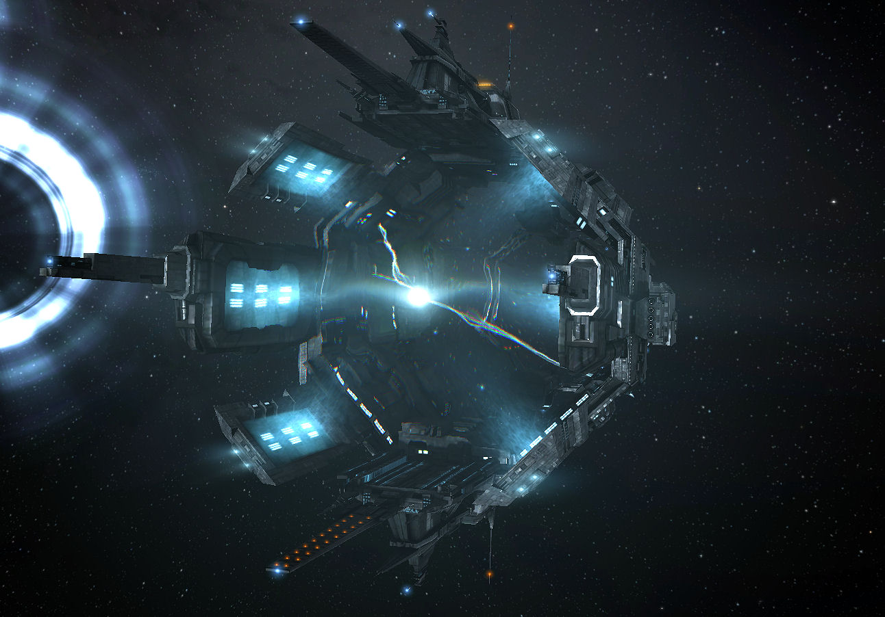
Ext. EntERPRISE
The Spacefold Gate lights up, the distortion field extruding through it.
The Enterprise's main deflector begins to glow, then the warp coils. Space begins to distort around them.
The space in front of the Enterprise seems to contract in on itself, the stars pulling closer to the ship, light bending in a hypnotic display.
Int. DEEP SPACE B-7 - Oviedo's office
Oviedo is holding a drink and looking out his large bay window at the Enterprise, poised at the now active gate.
OviEDO
"It matters not how strait the gate,"
Ext. EntERPRISE
The Enterprise sits ready in front of the gate as the Universe seems to rush at it, flattening before them.
OVIEDO (v.O.)
"How charged with punishments the scroll,"
Int. enTERPRISE - bridge
The bridge crew is speechless as they watch the viewscreen, they see the stars coming at them as if some giant hand were flattening the Universe.
Vega nods to Viin and she opens a special panel out of which a small holoscreen and control console emerge. A green light flashes indicating the Spacefold is active.
ViIN
Jump at your command, Sir.
Vega smiles and turns to Cole. He gestures to Cole, wanting him to give the command.
Cole smiles appreciatively and looks at the screen intently, looking into the artificial wormhole stretching out in front of him.
OVIEDO (v.O.)
"I am the master of my destiny,"
Cole closes his eyes and focuses on the moment. Everything around him slows and the sounds fade away.
Close up on Cole's eyes CUTS TO:
Ext. FrONTIER PLANET - night
Close up on Cole's eyes. They open. Stars are reflected in his eyes.
Cole, an adult, in his formal clothes, stands at the edge of the cliff over the lake by his home, looking into the reflected stars.
OviEDO (v.O.)
"I am the captain of my soul."
Cole looks up at the stars in the night sky.
He hears his father's voice.
FATHER (V.O.)
(softly)
Jump, Cole.
Cole
(in an awed whisper)
Jump.
The stars warp and stretch in his eyes, filled with the wonder of a young boy's dreams come true.
EXT. enteRPRISE
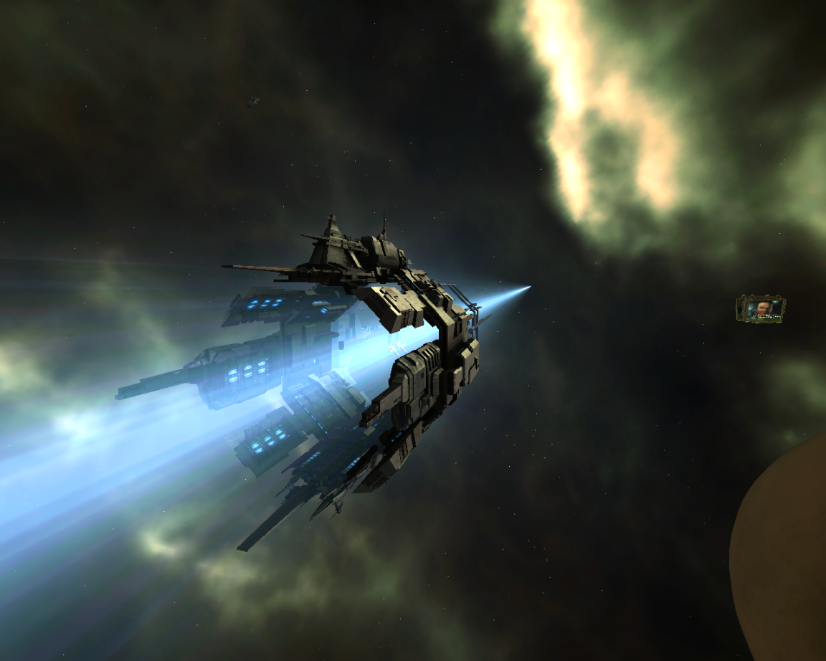
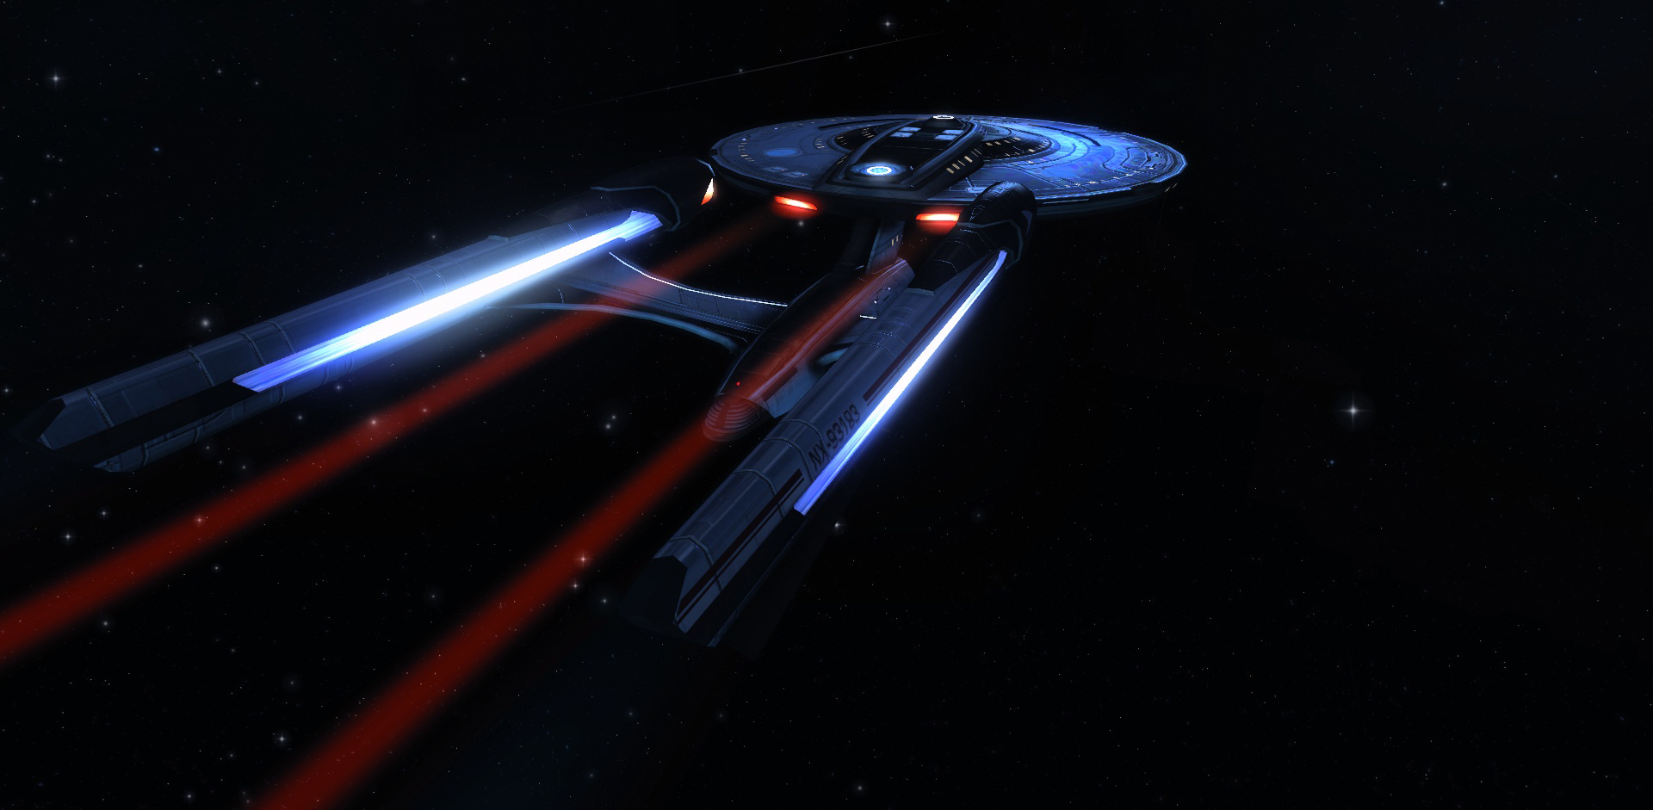
From behind the Enterprise, we see it stretch and shoot into the Spacefold Tunnel.
Ext. SPACE

Series Main Title Sequence

A starflield passes by the camera.
Cole (v.O.)
Space.
The final frontier.
The USS Enterprise passes by.
Cole (v.O.)
These are the voyages of the starship Enterprise.
The camera follows it towards the Spacefold Gate. The gate activates.
COLE (v.O.)
Its mission: to explore strange, new worlds.
To seek out new life, and new civilizations.
The Enterprise warps through the open gate.
COLE (V.O.)
To boldly go where no one has gone before.

The flies forward into the Andromeda Galaxy…
And stops on the night side of a planet, the horizon at the top of the screen.
As the planet lowers on the screen, the Enterprise rises from below, heading for the horizon as the series credits display over building music.
The planet lowers to the bottom 1/3 of the screen and the Enterprise reaches the horizon just as the sun appears over it. The Enterprise disappears into the glare of the sun and the series title appears above the horizon of the planet:
STAR TREK UNCHARTED

Int. DEEP SPACE B-7 - ovieDO'S OFFICE
Oviedo watches the Enterprise flash and disappear into the tunnel.
He turns, resting an arm on his desk. He looks simultaneously relieved and suddenly very tired and old. He holds up his glass as in a toast.
OVIEDO
(to himself)
Go get 'em, you lucky bastards.
He takes a drink from his glass.
INT. EnterPRISE - main engineering ring
Engineers are working busily, hurrying back and forth, monitoring their stations. Karnik is barking out orders, J'onn is nervously enduring the berating.
Slowly track in on a piece of equipment in the background. It is one of the Antimuon Generators that Viin pointed out earlier - that keep the wormhole tunnel stable. It appears to be humming along just fine.
The camera pulls around behind and underneath it to reveal a sinister looking sleek, black disc that looks completely out of place, just attached to the generator.
A red light on it begins blinking.
CUT TO BLACK
END OF PILOT

